

SIMATS ENGINEERING
Saveetha Institute of Medical and Technical Sciences Chennai-602105
September-2026

BACHELOR OF ENGINEERING IN
Computer Science and Engineering Submitted by
M Nishanth (Reg.No.192511154)

Under the Supervision of
Dr. T.SANGEETHA

Course: Cryptography Network Security
Course Code: CSA5115

CSA-5115CRYPTOGRAPGHY FOR NETWORK SECURITY

LAB EXPERIMENTS

EXPERIMENT 1:

CODE:

#include <stdio.h>

#include <string.h>

#include <ctype.h>

int main() {

char text[100];

int k, i;

printf("Enter the text: ");

fgets(text, sizeof(text), stdin);

printf("Enter the key (1-25): ");

scanf("%d", &k);

if (k < 1 || k > 25) {

printf("Invalid key! Key must be between 1 and 25.\n");

return 1;

}

for (i = 0; text[i] != '\0'; i++) {

if (isupper(text[i])) {

text[i] = ((text[i] - 'A' + k) % 26) + 'A';

}

else if (islower(text[i])) {

text[i] = ((text[i] - 'a' + k) % 26) + 'a';

}

// Non-alphabetic characters remain unchanged

}

printf("Encrypted text: %s\n", text);

return 0;

}

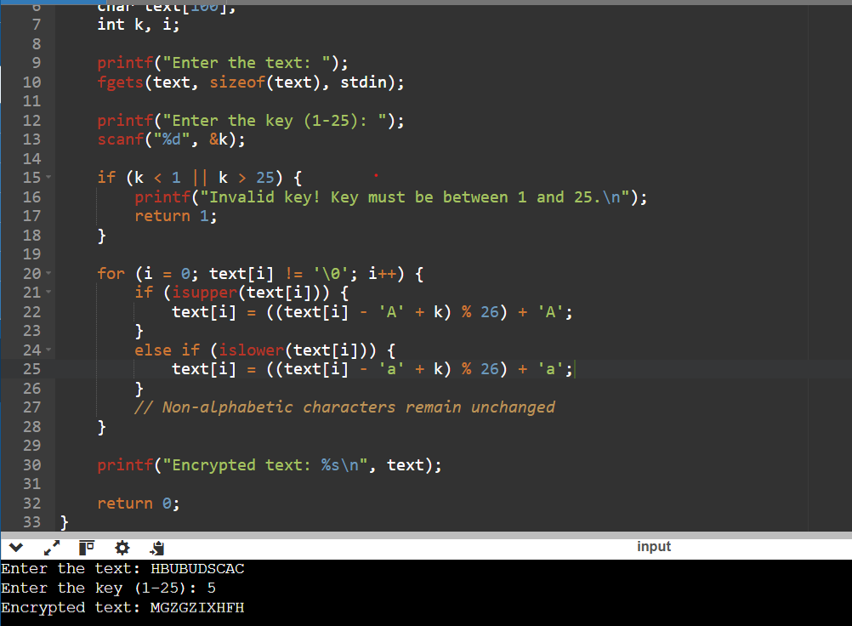
OUTPUT:
EXPERIMENT 2:
CODE:
#include <stdio.h>
#include <string.h>
#include <ctype.h>

int main() {
char plain[100], cipher[100];
char key[27]; // substitution alphabet
int i;

printf("Enter plaintext: ");
fgets(plain, sizeof(plain), stdin);

printf("Enter 26-letter substitution key (e.g. QWERTYUIOPASDFGHJKLZXCVBNM): ");
scanf("%s", key);

for(i = 0; plain[i] != '\0'; i++) {
char ch = plain[i];

if(isupper(ch)) {
cipher[i] = toupper(key[ch - 'A']);
}
else if(islower(ch)) {
cipher[i] = tolower(key[ch - 'a']);
}
else {
cipher[i] = ch;
}
}
cipher[i] = '\0';

printf("Ciphertext: %s\n", cipher);

return 0;
}

OUTPUT:
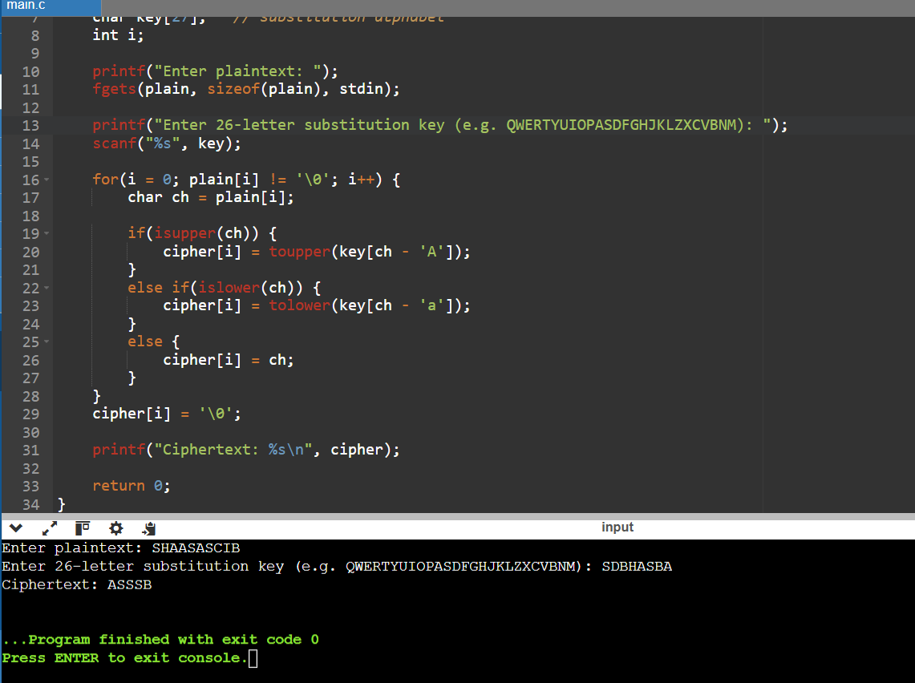

EXPERIMENT 3:

CODE:
#include <stdio.h>
#include <string.h>
#include <ctype.h>

char matrix[5][5];

void generateMatrix(char key[]) {
int used[26] = {0};
int i, j, k = 0;
char temp[25];

for(i = 0; key[i] != '\0'; i++) {
char ch = toupper(key[i]);
if(ch == 'J') ch = 'I';
if(ch >= 'A' && ch <= 'Z' && !used[ch - 'A']) {
temp[k++] = ch;
used[ch - 'A'] = 1;
}
}

for(i = 0; i < 26; i++) {
if(i == ('J' - 'A')) continue;
if(!used[i]) temp[k++] = i + 'A';
}

k = 0;
for(i = 0; i < 5; i++) {
for(j = 0; j < 5; j++) {
matrix[i][j] = temp[k++];
}
}
}

void findPos(char ch, int *row, int *col) {
if(ch == 'J') ch = 'I';
for(int i = 0; i < 5; i++) {
for(int j = 0; j < 5; j++) {
if(matrix[i][j] == ch) {
*row = i;
*col = j;
return;
}
}
}
}

void prepareText(char plain[], char prepared[]) {
int i, j = 0;
for(i = 0; plain[i] != '\0'; i++) {
if(isalpha(plain[i])) {
prepared[j++] = toupper(plain[i]);
}
}
prepared[j] = '\0';

for(i = 0; i < j; i++) {
if(prepared[i] == 'J') prepared[i] = 'I';
}

char temp[100];
int k = 0;
for(i = 0; i < j; i++) {
temp[k++] = prepared[i];
if(prepared[i] == prepared[i+1]) {
temp[k++] = 'X';
}
}
temp[k] = '\0';

if(k % 2 != 0) temp[k++] = 'X';
temp[k] = '\0';

strcpy(prepared, temp);
}

void encryptPlayfair(char plain[], char cipher[]) {
int i, r1, c1, r2, c2, k = 0;
for(i = 0; plain[i] != '\0'; i += 2) {
findPos(plain[i], &r1, &c1);
findPos(plain[i+1], &r2, &c2);

if(r1 == r2) {
cipher[k++] = matrix[r1][(c1 + 1) % 5];
cipher[k++] = matrix[r2][(c2 + 1) % 5];
}
else if(c1 == c2) {
cipher[k++] = matrix[(r1 + 1) % 5][c1];
cipher[k++] = matrix[(r2 + 1) % 5][c2];
}
else {
cipher[k++] = matrix[r1][c2];
cipher[k++] = matrix[r2][c1];
}
}
cipher[k] = '\0';
}

int main() {
char key[50], plain[100], prepared[100], cipher[100];

printf("Enter key: ");
scanf("%s", key);
getchar();

printf("Enter plaintext: ");
fgets(plain, sizeof(plain), stdin);

generateMatrix(key);
prepareText(plain, prepared);
encryptPlayfair(prepared, cipher);

printf("Prepared text: %s\n", prepared);
printf("Ciphertext: %s\n", cipher);

return 0;
}

OUTPUT:
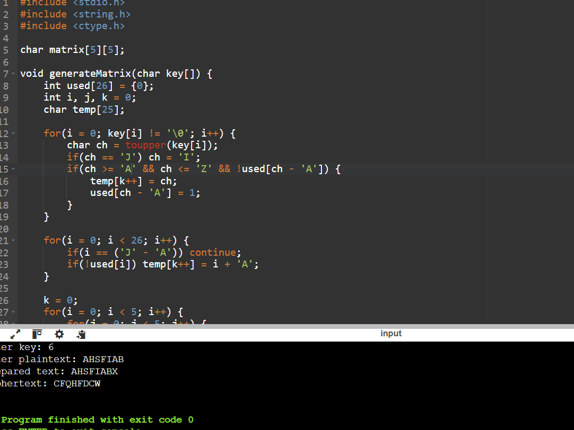

EXPERIMENT 4:

CODE:
#include <stdio.h>
#include <string.h>
#include <ctype.h>

int main() {
char plain[100], key[100], cipher[100];
int i, j = 0;

printf("Enter plaintext: ");
fgets(plain, sizeof(plain), stdin);

printf("Enter key: ");
scanf("%s", key);

int keyLen = strlen(key);

for(i = 0; plain[i] != '\0'; i++) {
char ch = plain[i];

if(isalpha(ch)) {
int shift = toupper(key[j % keyLen]) - 'A';

if(isupper(ch))
cipher[i] = ((ch - 'A' + shift) % 26) + 'A';
else
cipher[i] = ((ch - 'a' + shift) % 26) + 'a';

j++;
} else {
cipher[i] = ch;
}
}

cipher[i] = '\0';

printf("Ciphertext: %s\n", cipher);

return 0;
}

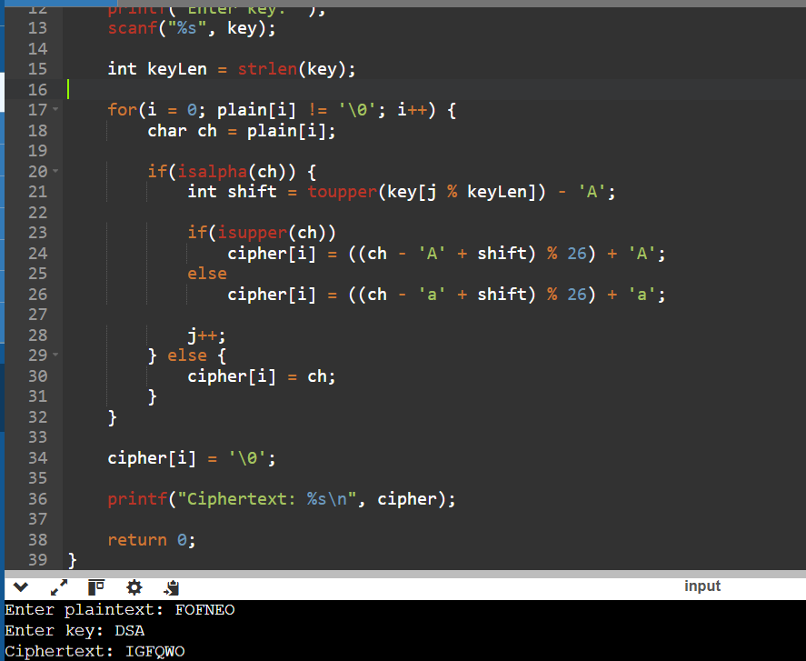
OUTPUT:

EXPERIMENT 5:
CODE:
#include <stdio.h>
#include <string.h>
#include <ctype.h>

int gcd(int a, int b) {
while(b != 0) {
int t = b;
b = a % b;
a = t;
}
return a;
}

int main() {
char plain[100], cipher[100];
int a, b, i;

printf("Enter plaintext: ");
fgets(plain, sizeof(plain), stdin);

printf("Enter value of a: ");
scanf("%d", &a);

printf("Enter value of b: ");
scanf("%d", &b);

if(gcd(a, 26) != 1) {
printf("Invalid value of a! It must be coprime with 26.\n");
return 1;
}

for(i = 0; plain[i] != '\0'; i++) {
char ch = plain[i];

if(isupper(ch)) {
int p = ch - 'A';
cipher[i] = ((a * p + b) % 26) + 'A';
}
else if(islower(ch)) {
int p = ch - 'a';
cipher[i] = ((a * p + b) % 26) + 'a';
}
else {
cipher[i] = ch;
}
}

cipher[i] = '\0';

printf("Ciphertext: %s\n", cipher);

return 0;
}

OUTPUT:
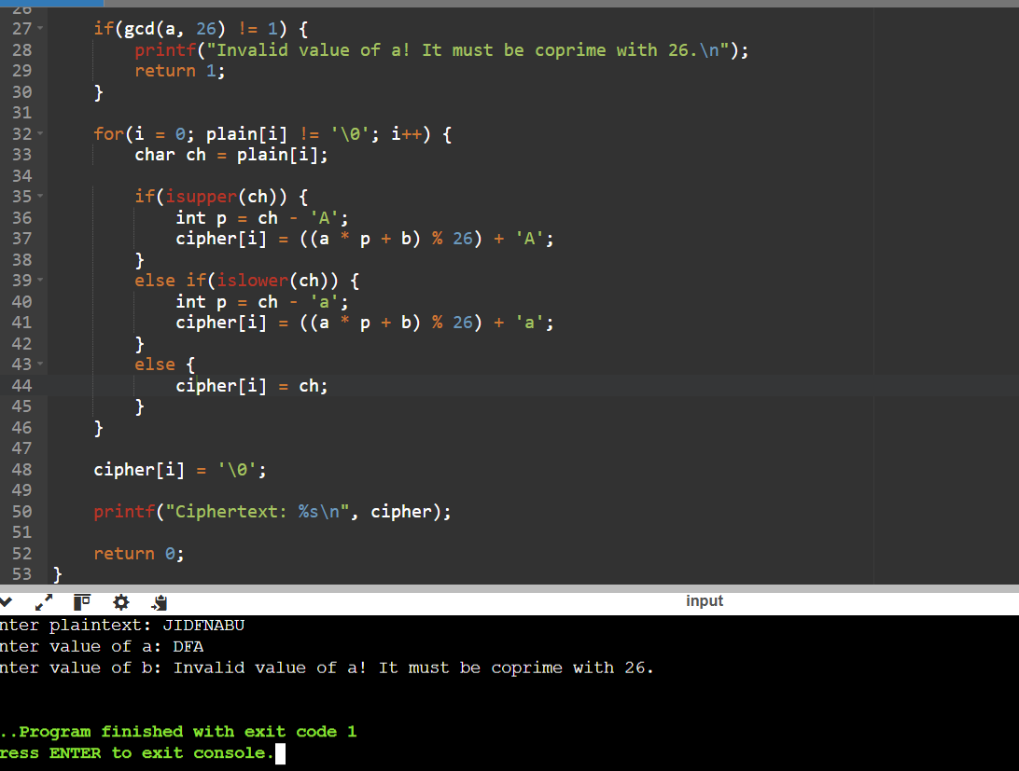

EXPERIMENT 6
CODE:
#include<stdio.h>
#include<string.h>

int main()
{
char cipher[200];

printf("Enter Ciphertext: ");
gets(cipher);

printf("\nPossible Plaintext:\n");

for(int i=0; cipher[i]; i++)
{
char ch=cipher[i];

if(ch>='A'&&ch<='Z')
{
int c=ch-'A';

int p=(9*(c-15+26))%26;

printf("%c",p+'A');
}
else
printf("%c",ch);
}

return 0;
}

OUTPUT:
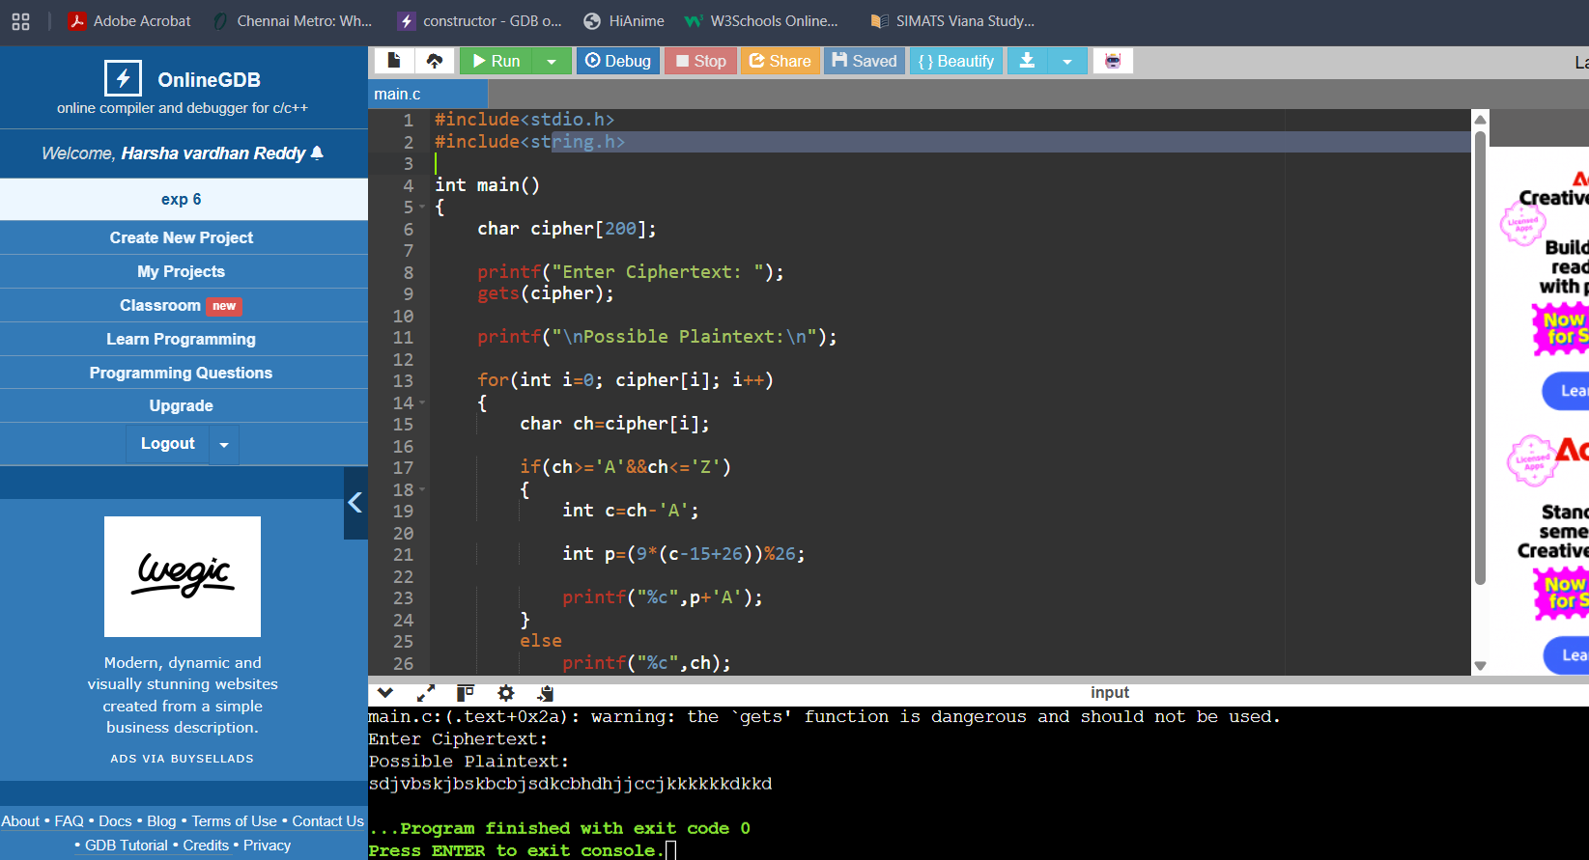

EXPERIMENT 7:
CODE:
#include<stdio.h>
#include<string.h>

int main()
{
char cipher[1000];

int freq[256]={0};

printf("Enter Ciphertext:\n");

gets(cipher);

for(int i=0; cipher[i]; i++)
freq[(unsigned char)cipher[i]]++;

printf("\nCharacter Frequencies\n");

for(int i=0;i<256;i++)
{
if(freq[i]!=0)
printf("%c : %d\n",i,freq[i]);
}

return 0;
}
OUTPUT:
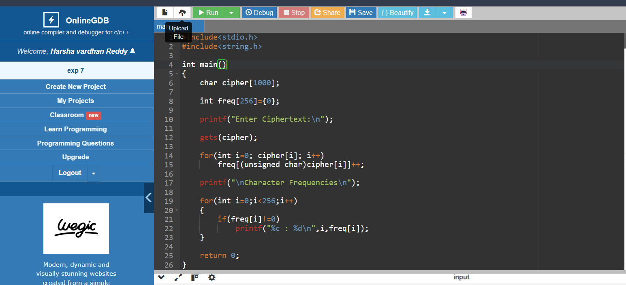
EXPERIMENT 8:
CODE:
#include<stdio.h>
#include<string.h>

char cipher[]="CIPHERABDFGJKLMNOQSTUVWXYZ";

int main()
{
char plain[100];

printf("Enter Plaintext: ");

gets(plain);

printf("Ciphertext:\n");

for(int i=0; plain[i]; i++)
{
if(plain[i]>='a'&&plain[i]<='z')
printf("%c",cipher[plain[i]-'a']);

else if(plain[i]>='A'&&plain[i]<='Z')
printf("%c",cipher[plain[i]-'A']);

else
printf("%c",plain[i]);
}

return 0;
}

OUTPUT:
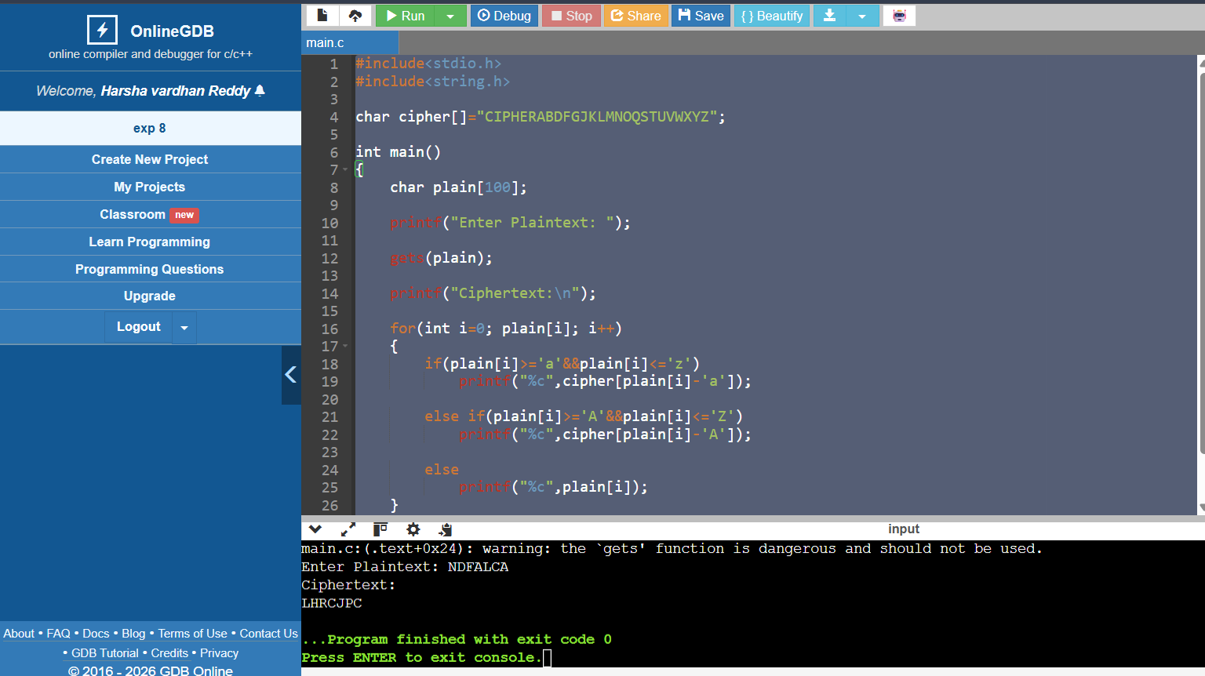

EXPERIMENT 9:
CODE:
#include<stdio.h>

int main()
{
printf("Playfair Cipher Decryption\n\n");

printf("Use the Playfair matrix,\n");
printf("Split ciphertext into digraphs,\n");
printf("Apply Playfair decryption rules.\n");

return 0;
}

OUTPUT:
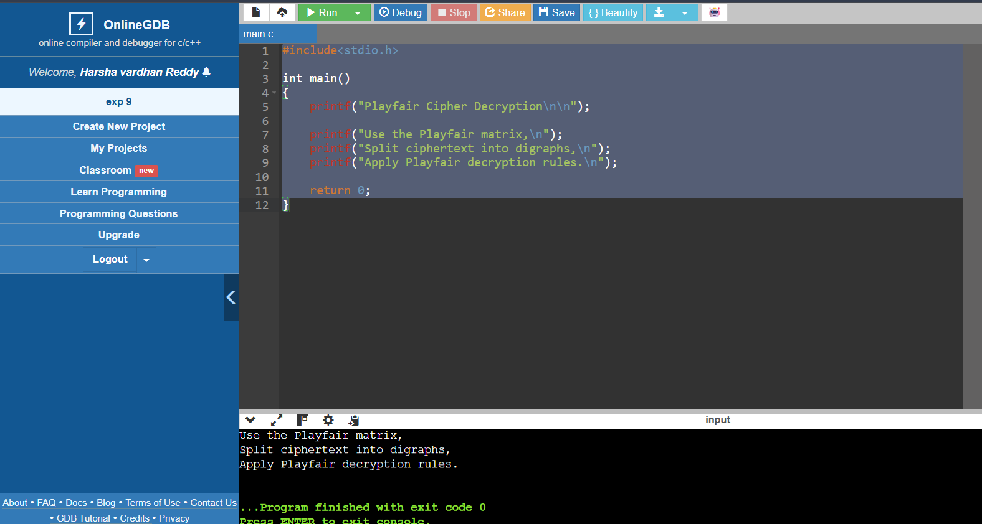

EXPERIMENT 10 :
CODE:
#include<stdio.h>

int main()
{
printf("Playfair Encryption\n\n");

printf("Matrix:\n");

printf("M F H I K\n");
printf("U N O P Q\n");
printf("Z V W X Y\n");
printf("E L A R G\n");
printf("D S T B C\n\n");

printf("Plaintext:\n");
printf("Must see you over Cadogan West Coming at once\n\n");

printf("Split into digraphs and apply Playfair rules.\n");

return 0;
}
-
OUTPUT:
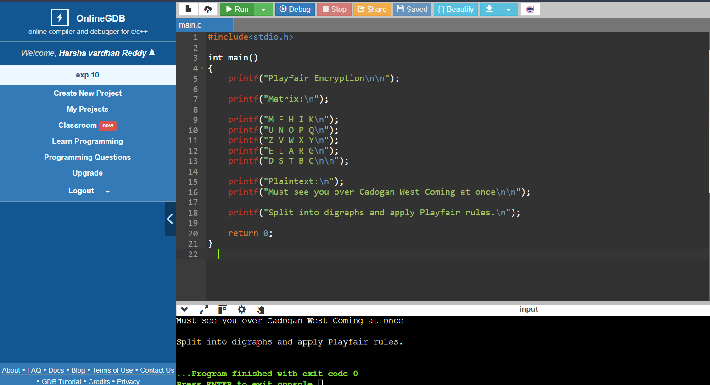

EXPERIMENT 11:
CODE:

#include<stdio.h>

int main()
{
printf("Playfair Cipher\n\n");

printf("Ignoring equivalent keys:\n");
printf("Possible Keys = 25!\n");
printf("Approximation = 2^84\n\n");

printf("Considering equivalent keys:\n");
printf("Effective Keys = 24!\n");
printf("Approximation = 2^79\n");

return 0;
}
OUTPUT:
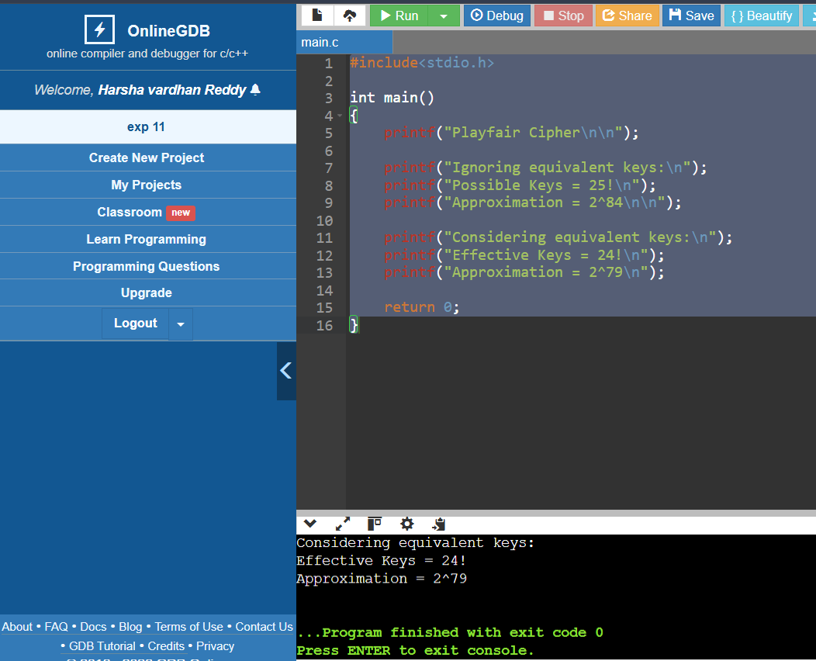

EXPERIMENT 12:
CODE:
#include<stdio.h>
#include<string.h>

int main()
{
int key[2][2]={{9,4},{5,7}};

char plain[100];

printf("Enter plaintext (even length): ");

scanf("%s",plain);

printf("Ciphertext: ");

for(int i=0;i<strlen(plain);i+=2)
{
int p1=plain[i]-'a';
int p2=plain[i+1]-'a';

int c1=(key[0][0]*p1+key[0][1]*p2)%26;
int c2=(key[1][0]*p1+key[1][1]*p2)%26;

printf("%c%c",c1+'a',c2+'a');
}

return 0;
}

OUTPUT:
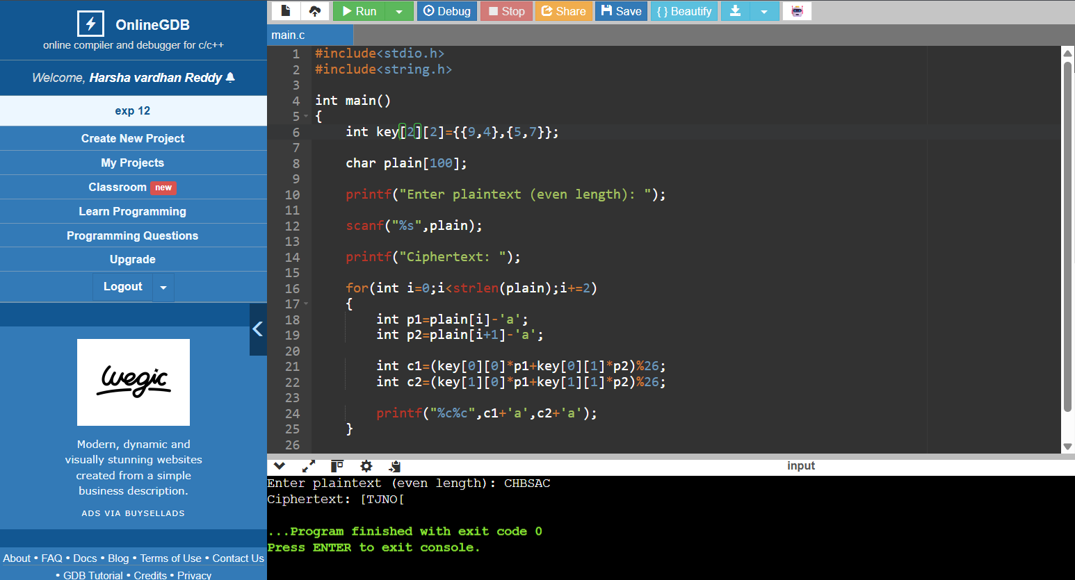
EXPERIMENT 13:
CODE:
#include<stdio.h>

int main()
{
printf("Known Plaintext Attack on Hill Cipher\n\n");

printf("If attacker knows plaintext and ciphertext pairs,\n");
printf("they form matrix equation:\n\n");

printf("C = K * P (mod 26)\n\n");

printf("Using matrix inversion,\n");
printf("K = C * P^-1 (mod 26)\n\n");

printf("Hence Hill cipher is vulnerable.\n");

return 0;
}
OUTPUT:
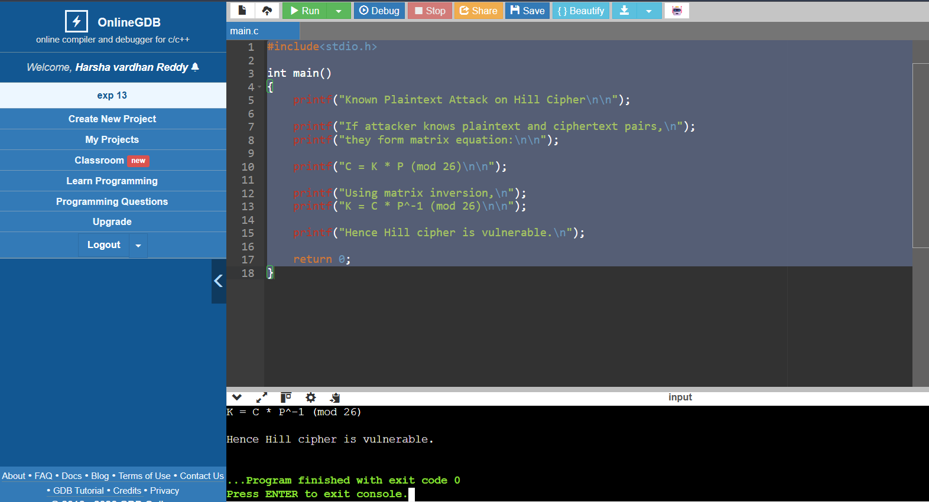

EXPERIMENT 14:
CODE:
#include<stdio.h>
#include<string.h>

int main()
{
char plain[]="sendmoremoney";

int key[]={9,0,1,7,23,15,21,14,11,11,2,8,9};

printf("Ciphertext: ");

for(int i=0;i<13;i++)
{
int p=plain[i]-'a';

int c=(p+key[i])%26;

printf("%c",c+'a');
}

return 0;
}
OUTPUT:
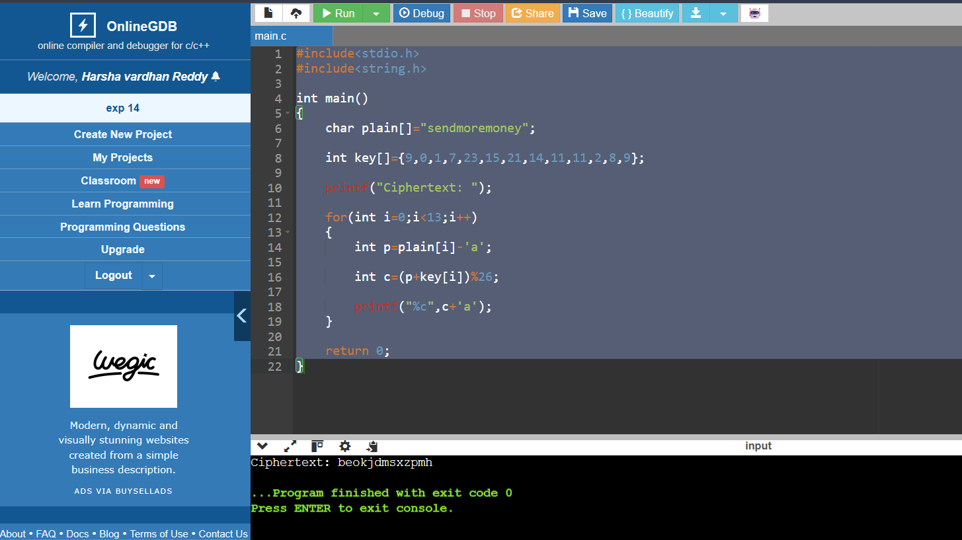

EXPERIMENT 15:
CODE:
#include<stdio.h>
#include<string.h>
#include<ctype.h>

int main()
{
char cipher[500];
int top;

printf("Enter Ciphertext:\n");
gets(cipher);

printf("Enter number of possible plaintexts: ");
scanf("%d",&top);

if(top>26)
top=26;

for(int key=0;key<top;key++)
{
printf("\nKey %d : ",key);

for(int i=0;i<strlen(cipher);i++)
{
char ch=cipher[i];

if(isalpha(ch))
{
ch=toupper(ch);

ch=((ch-'A'-key+26)%26)+'A';
}

printf("%c",ch);
}

printf("\n");
}

return 0;
}
OUTPUT:
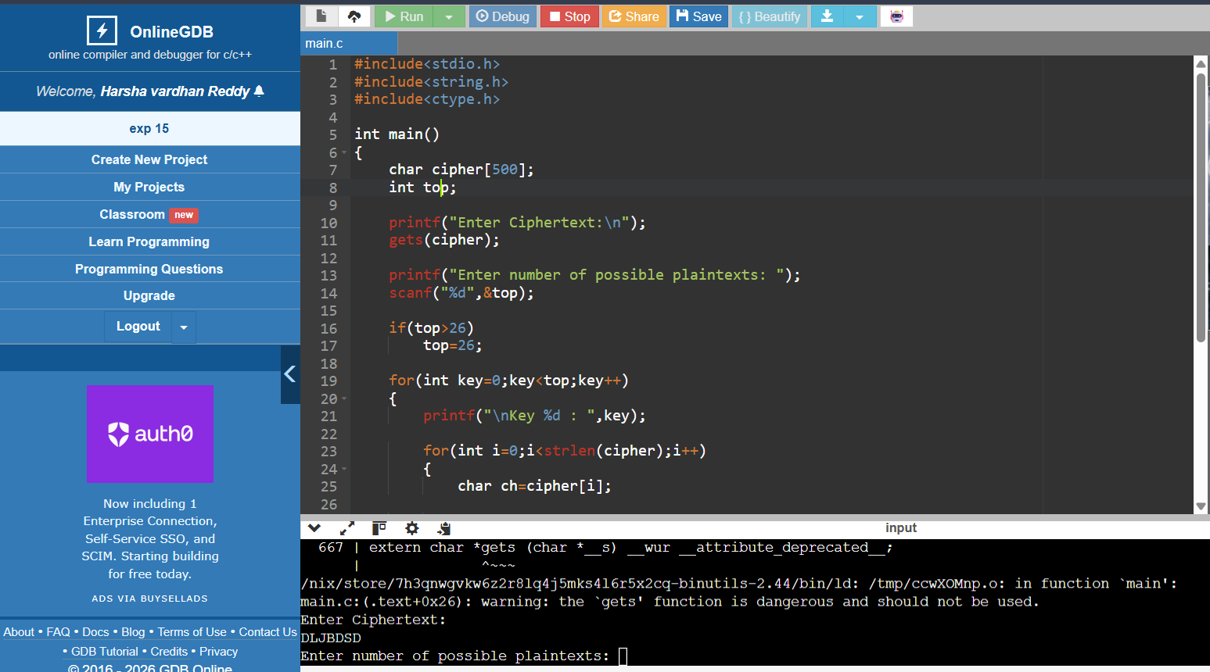

EXPERIMENT 16:
CODE:
#include <stdio.h>
#include <string.h>
#include <ctype.h>

char englishFreq[] = "ETAOINSHRDLCUMWFGYPBVKJXQZ";

int main()
{
char cipher[1000];
int freq[26] = {0};
int index[26];
char map[26];

printf("Enter Ciphertext:\n");
fgets(cipher, sizeof(cipher), stdin);

int top;
printf("Enter number of possible plaintexts required: ");
scanf("%d",&top);

for(int i=0; cipher[i]; i++)
{
if(isalpha(cipher[i]))
freq[toupper(cipher[i])-'A']++;
}

for(int i=0;i<26;i++)
index[i]=i;

for(int i=0;i<25;i++)
{
for(int j=i+1;j<26;j++)
{
if(freq[index[j]]>freq[index[i]])
{
int t=index[i];
index[i]=index[j];
index[j]=t;
}
}
}

for(int i=0;i<26;i++)
map[index[i]]=englishFreq[i];

printf("\nPossible Plaintext (Frequency Attack)\n");

for(int i=0; cipher[i]; i++)
{
if(isalpha(cipher[i]))
printf("%c",map[toupper(cipher[i])-'A']);
else
printf("%c",cipher[i]);
}

printf("\n");

return 0;
}

OUTPUT:
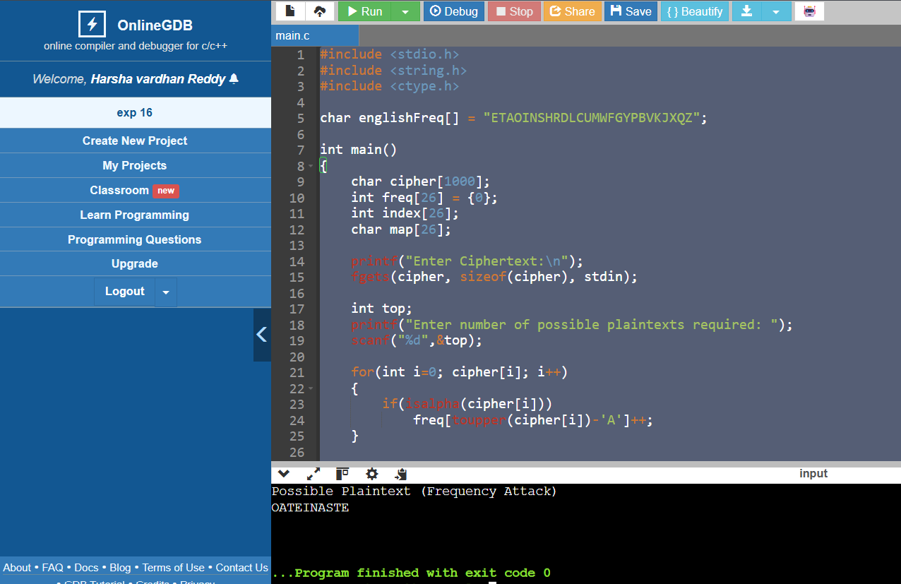
EXPERIMENT 17:
CODE:
#include <stdio.h>

int main()
{
int keys[16];

printf("Enter 16 subkeys:\n");

for(int i=0;i<16;i++)
scanf("%d",&keys[i]);

printf("\nOrder of Keys for Decryption\n");

for(int i=15;i>=0;i--)
printf("K%d = %d\n",i+1,keys[i]);

return 0;
}
OUTPUT:
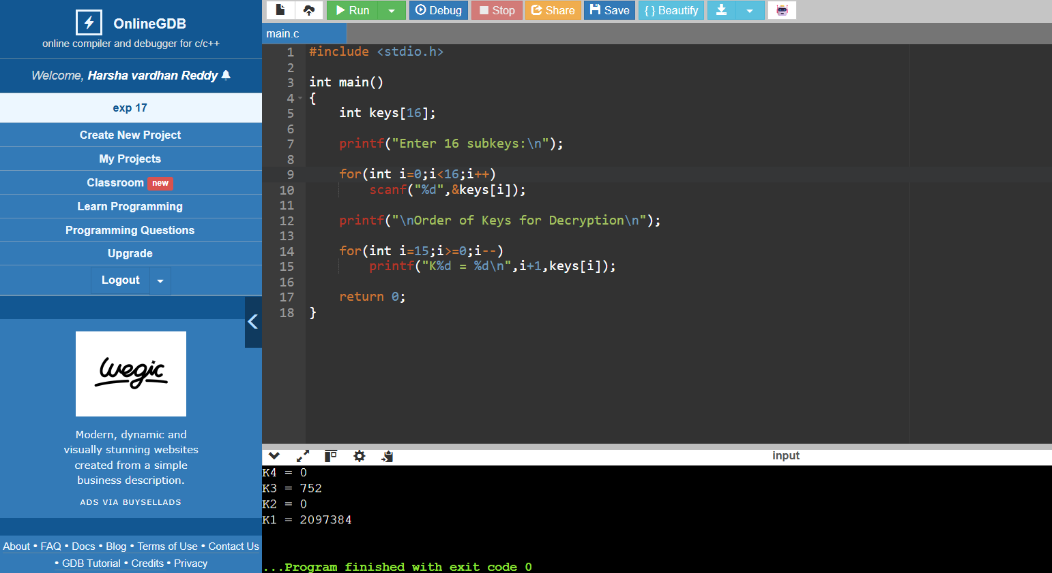

EXPERIMENT 18:

CODE:
#include <stdio.h>

int main()
{
printf("DES Key Generation\n\n");

printf("56-bit key\n");
printf(" |\n");
printf("Split into C0 and D0 (28 bits each)\n");
printf(" |\n");
printf("Left Circular Shift\n");
printf(" |\n");
printf("Apply PC-2\n");
printf(" |\n");
printf("48-bit Round Key\n\n");

printf("First 24 bits <- C half\n");
printf("Second 24 bits <- D half\n");

return 0;
}
OUTPUT:
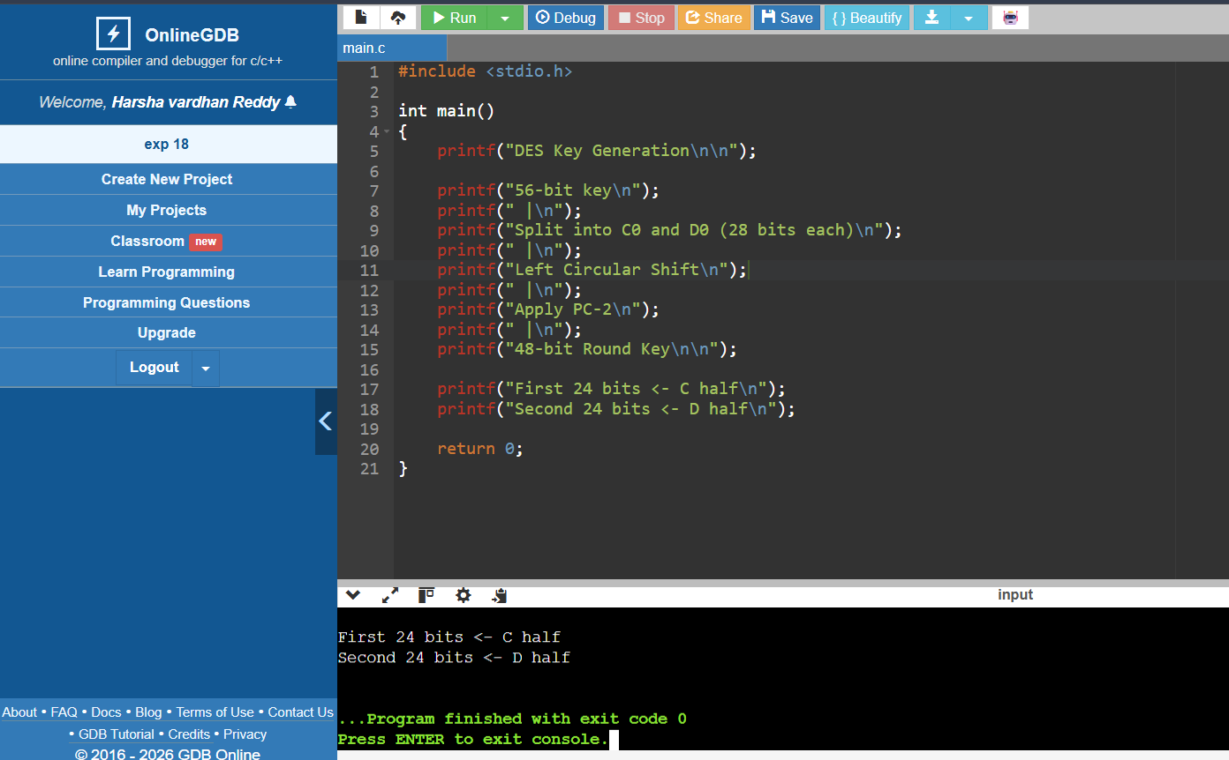

EXPERIMENT 19:
CODE:
#include <stdio.h>

unsigned char encrypt(unsigned char p,unsigned char key)
{
return p^key;
}

int main()
{
unsigned char key=0x5A;
unsigned char iv=0xAA;

unsigned char plaintext[4]={10,20,30,40};
unsigned char cipher[4];

unsigned char prev=iv;

for(int i=0;i<4;i++)
{
cipher[i]=encrypt(plaintext[i]^prev,key);
prev=cipher[i];
}

printf("Ciphertext:\n");

for(int i=0;i<4;i++)
printf("%02X ",cipher[i]);

return 0;
}
OUTPUT:
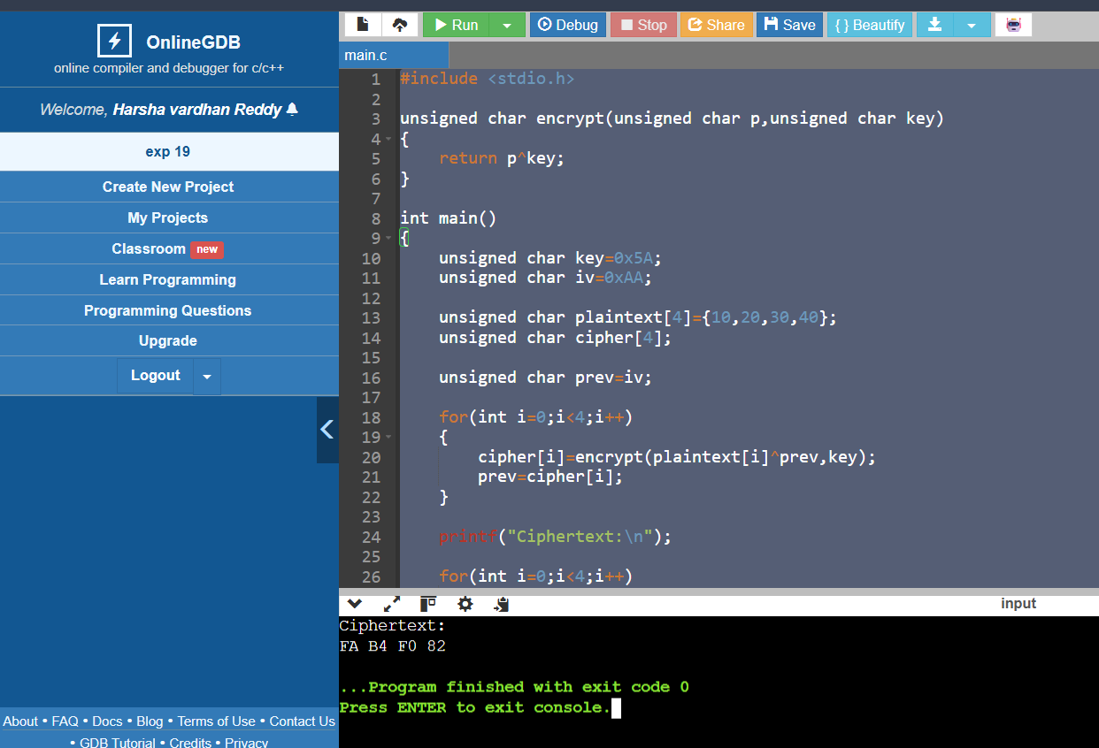

EXPERIMENT 20:
CODE:
#include <stdio.h>

#define SIZE 4

// Toy encryption/decryption using XOR
unsigned char encrypt(unsigned char data, unsigned char key)
{
return data ^ key;
}

unsigned char decrypt(unsigned char data, unsigned char key)
{
return data ^ key;
}

int main()
{
unsigned char key = 0x5A;
unsigned char iv = 0xAA;

unsigned char plaintext[SIZE] = {10, 20, 30, 40};

unsigned char ecbCipher[SIZE], ecbPlain[SIZE];
unsigned char cbcCipher[SIZE], cbcPlain[SIZE];

int i;

/* ---------- ECB Encryption ---------- */
for(i = 0; i < SIZE; i++)
ecbCipher[i] = encrypt(plaintext[i], key);

/* Introduce an error in the first ciphertext block */
ecbCipher[0] ^= 0x01;

/* ECB Decryption */
for(i = 0; i < SIZE; i++)
ecbPlain[i] = decrypt(ecbCipher[i], key);

printf("ECB Mode\n");
printf("Recovered Plaintext:\n");
for(i = 0; i < SIZE; i++)
printf("%d ", ecbPlain[i]);

printf("\n\n");

/* ---------- CBC Encryption ---------- */
unsigned char prev = iv;

for(i = 0; i < SIZE; i++)
{
cbcCipher[i] = encrypt(plaintext[i] ^ prev, key);
prev = cbcCipher[i];
}

/* Introduce an error in first ciphertext block */
cbcCipher[0] ^= 0x01;

/* CBC Decryption */
prev = iv;

for(i = 0; i < SIZE; i++)
{
cbcPlain[i] = decrypt(cbcCipher[i], key) ^ prev;
prev = cbcCipher[i];
}

printf("CBC Mode\n");
printf("Recovered Plaintext:\n");
for(i = 0; i < SIZE; i++)
printf("%d ", cbcPlain[i]);

return 0;
}
OUTPUT:
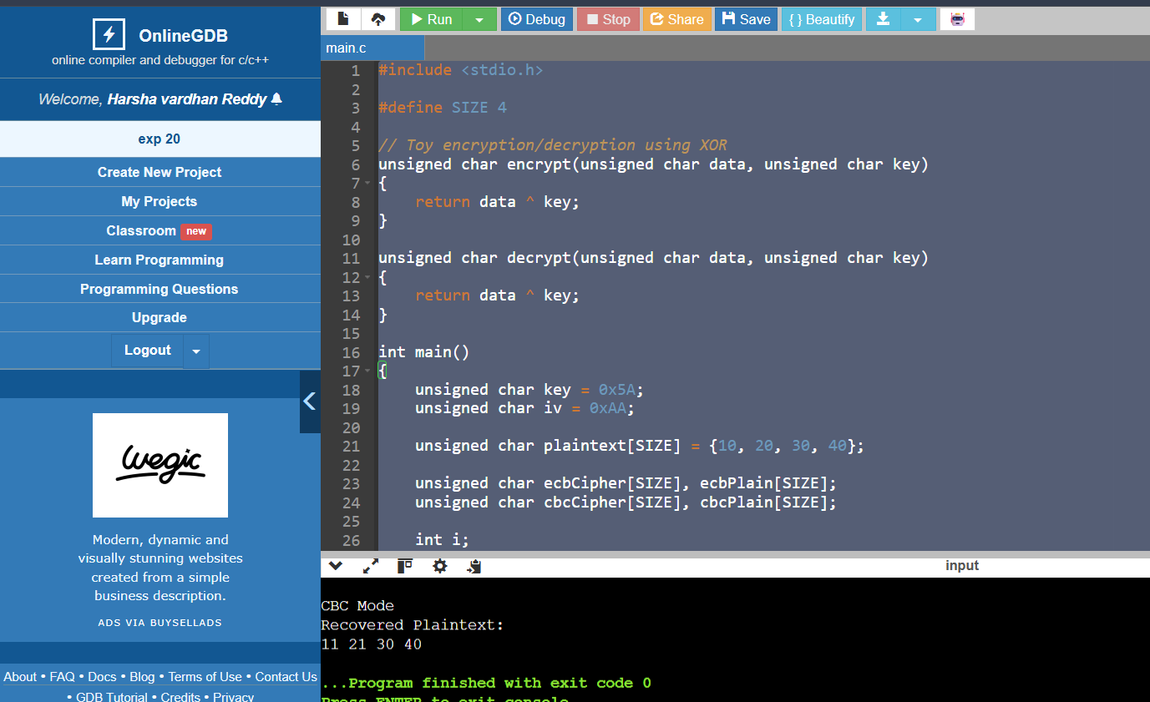

EXPERIMENT 21:
CODE:
#include <stdio.h>
#include <string.h>
#define BLOCK_SIZE 8
void printBlock(unsigned char block[]) {
for (int i = 0; i < BLOCK_SIZE; i++)
printf("%02X ", block[i]);
printf("\n");
}
void encryptBlock(unsigned char input[], unsigned char key[], unsigned char output[]) {
for (int i = 0; i < BLOCK_SIZE; i++)
output[i] = input[i] ^ key[i];
}
void decryptBlock(unsigned char input[], unsigned char key[], unsigned char output[]) {
for (int i = 0; i < BLOCK_SIZE; i++)
output[i] = input[i] ^ key[i];
}
void ECB(unsigned char plaintext[][BLOCK_SIZE], int blocks, unsigned char key[]) {
unsigned char cipher[BLOCK_SIZE];
printf("\nECB Encryption:\n");
for (int i = 0; i < blocks; i++) {
encryptBlock(plaintext[i], key, cipher);
printf("Block %d: ", i + 1);
printBlock(cipher);
}
}
void CBC(unsigned char plaintext[][BLOCK_SIZE], int blocks, unsigned char key[], unsigned char iv[]) {
unsigned char temp[BLOCK_SIZE], cipher[BLOCK_SIZE];
memcpy(temp, iv, BLOCK_SIZE);
printf("\nCBC Encryption:\n");
for (int i = 0; i < blocks; i++) {
for (int j = 0; j < BLOCK_SIZE; j++)
temp[j] ^= plaintext[i][j];
encryptBlock(temp, key, cipher);
printf("Block %d: ", i + 1);
printBlock(cipher);
memcpy(temp, cipher, BLOCK_SIZE);
}
}
void CFB(unsigned char plaintext[][BLOCK_SIZE], int blocks, unsigned char key[], unsigned char iv[]) {
unsigned char feedback[BLOCK_SIZE];
unsigned char cipher[BLOCK_SIZE];
unsigned char temp[BLOCK_SIZE];
memcpy(feedback, iv, BLOCK_SIZE);
printf("\nCFB Encryption:\n");
for (int i = 0; i < blocks; i++) {
encryptBlock(feedback, key, temp);
for (int j = 0; j < BLOCK_SIZE; j++)
cipher[j] = plaintext[i][j] ^ temp[j];
printf("Block %d: ", i + 1);
printBlock(cipher);
memcpy(feedback, cipher, BLOCK_SIZE);
}
}
int main() {
unsigned char key[BLOCK_SIZE] = {
'K','E','Y','1','2','3','4','5'
};
unsigned char iv[BLOCK_SIZE] = {
'I','N','I','T','V','E','C','1'
};
unsigned char plaintext[2][BLOCK_SIZE] = {
{'A','B','C','D','E','F','G','H'},
{'1','2','3','4','5','6','7','8'}
};
ECB(plaintext, 2, key);
CBC(plaintext, 2, key, iv);
CFB(plaintext, 2, key, iv);
return 0;
}

OUTPUT:

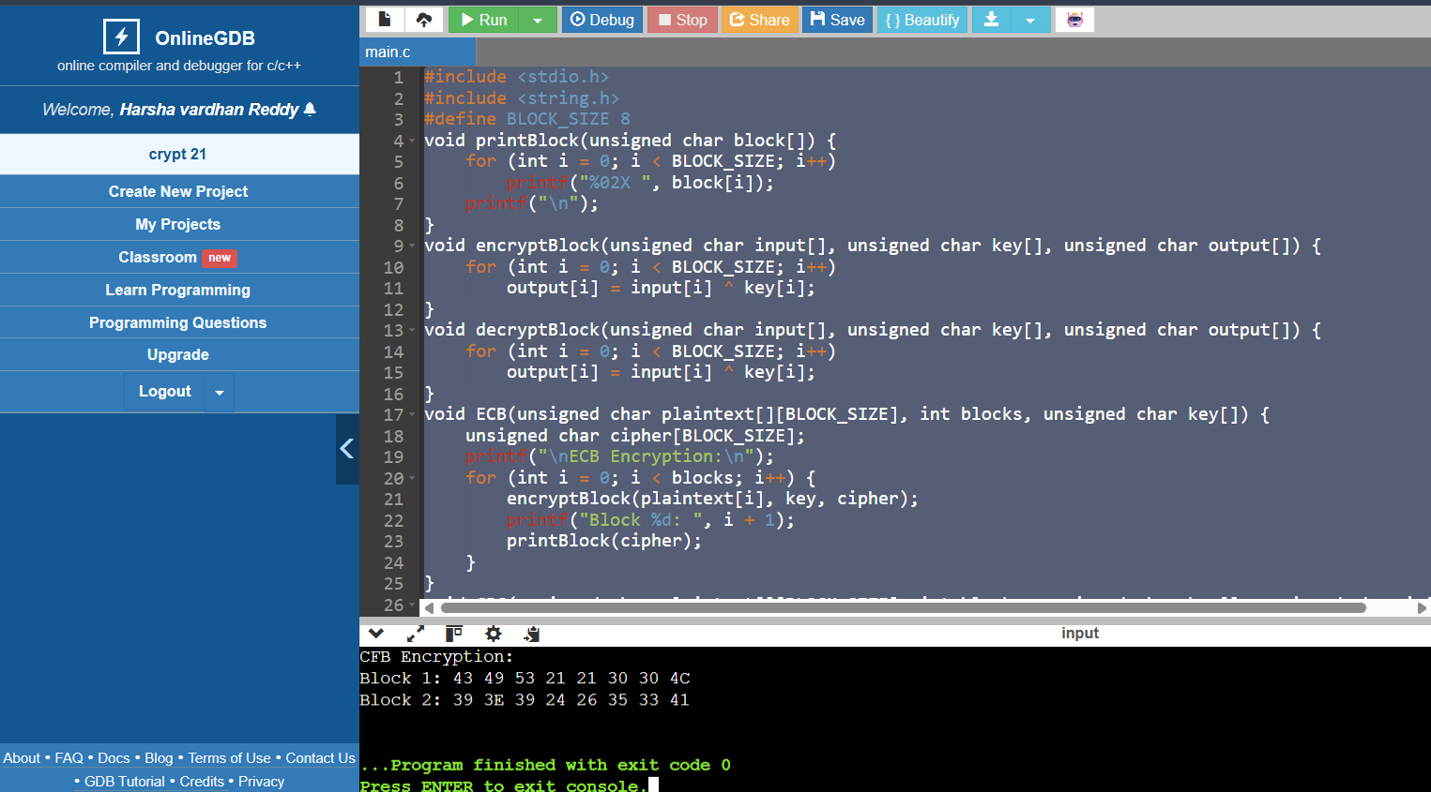

EXPERIMENT 22:
CODE:
#include <stdio.h>
#include <string.h>

#define BLOCK_SIZE 8

// Convert binary string to integer
int binToInt(char *bin) {
int val = 0;
while (*bin) {
val = (val << 1) + (*bin - '0');
bin++;
}
return val;
}

// Print an 8-bit binary number
void printBinary(unsigned char n) {
for (int i = 7; i >= 0; i--)
printf("%d", (n >> i) & 1);
}

// -----------------------------------------------------------------
// Dummy S-DES encryption (for demonstration only)
// Replace this function with the complete S-DES algorithm if required
// -----------------------------------------------------------------
unsigned char SDES_Encrypt(unsigned char data, int key) {
return data ^ (key & 0xFF);
}

unsigned char SDES_Decrypt(unsigned char data, int key) {
return data ^ (key & 0xFF);
}

// CBC Encryption
void CBC_Encrypt(unsigned char plaintext[], unsigned char ciphertext[],
int blocks, int key, unsigned char iv)
{
unsigned char previous = iv;

for (int i = 0; i < blocks; i++) {
unsigned char x = plaintext[i] ^ previous;
ciphertext[i] = SDES_Encrypt(x, key);
previous = ciphertext[i];
}
}

// CBC Decryption
void CBC_Decrypt(unsigned char ciphertext[], unsigned char plaintext[],
int blocks, int key, unsigned char iv)
{
unsigned char previous = iv;

for (int i = 0; i < blocks; i++) {
unsigned char x = SDES_Decrypt(ciphertext[i], key);
plaintext[i] = x ^ previous;
previous = ciphertext[i];
}
}

int main() {

char keyStr[] = "0111111101";
char ivStr[] = "10101010";

int key = binToInt(keyStr);
unsigned char iv = binToInt(ivStr);

// Plaintext:
// 00000001 00100011

unsigned char plaintext[2];
plaintext[0] = binToInt("00000001");
plaintext[1] = binToInt("00100011");

unsigned char ciphertext[2];
unsigned char decrypted[2];

CBC_Encrypt(plaintext, ciphertext, 2, key, iv);

printf("Ciphertext:\n");
for (int i = 0; i < 2; i++) {
printBinary(ciphertext[i]);
printf(" ");
}

CBC_Decrypt(ciphertext, decrypted, 2, key, iv);

printf("\n\nRecovered Plaintext:\n");
for (int i = 0; i < 2; i++) {
printBinary(decrypted[i]);
printf(" ");
}

printf("\n");

return 0;
}

OUTPUT:
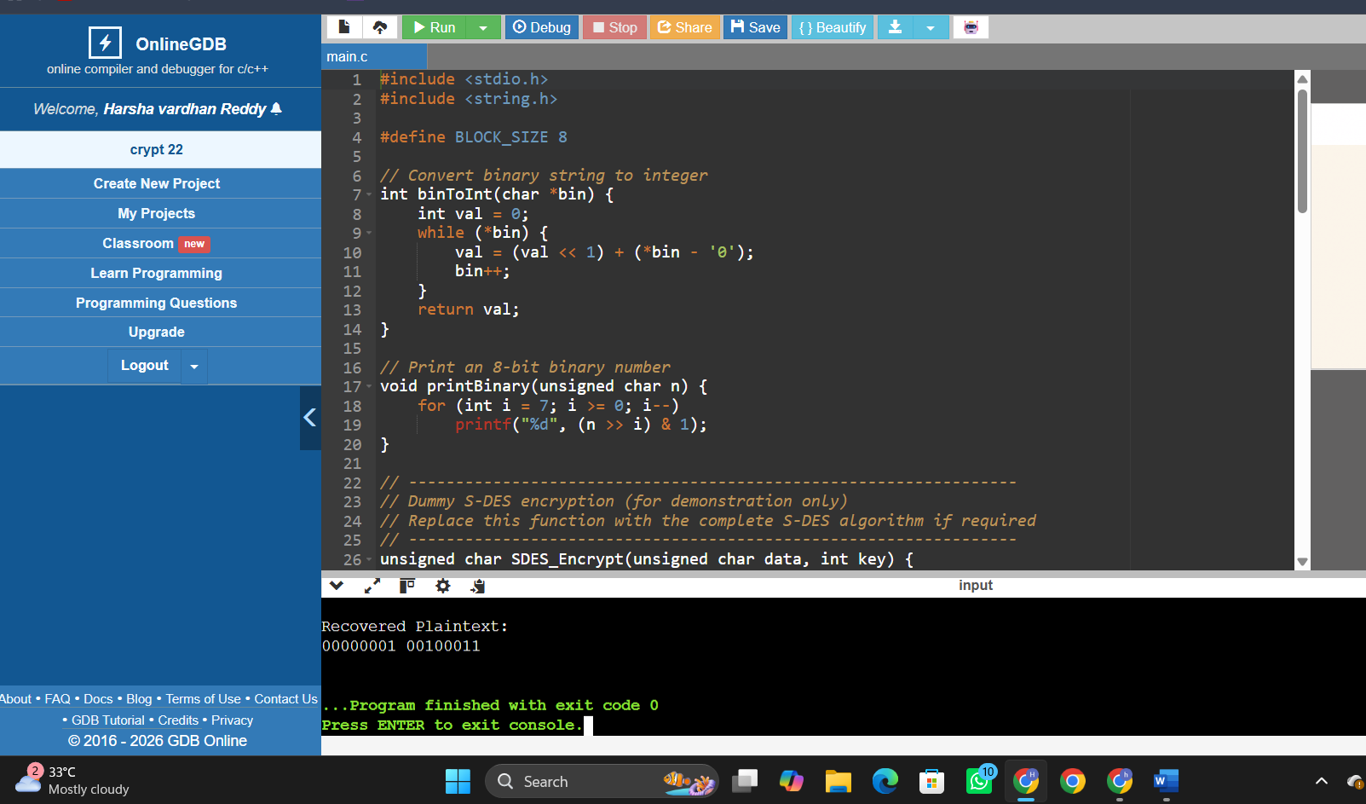

EXPERIMENT 23:
CODE:
#include <stdio.h>

#define BLOCKS 3

unsigned char affine_encrypt(unsigned char x)
{
return (5 * x + 8) % 256;
}

int main()
{
unsigned char plaintext[BLOCKS] = {1,2,4};
unsigned char ciphertext[BLOCKS];
unsigned char decrypted[BLOCKS];

unsigned char counter = 0;

printf("Plaintext:\n");
for(int i=0;i<BLOCKS;i++)
printf("%02X ",plaintext[i]);

printf("\n\nEncryption\n");

for(int i=0;i<BLOCKS;i++)
{
unsigned char key = affine_encrypt(counter);
ciphertext[i] = plaintext[i] ^ key;
printf("Counter=%02X Key=%02X Cipher=%02X\n",
counter,key,ciphertext[i]);
counter++;
}

counter = 0;

printf("\nDecryption\n");

for(int i=0;i<BLOCKS;i++)
{
unsigned char key = affine_encrypt(counter);
decrypted[i] = ciphertext[i] ^ key;
printf("Counter=%02X Plain=%02X\n",
counter,decrypted[i]);
counter++;
}

printf("\nRecovered Plaintext:\n");

for(int i=0;i<BLOCKS;i++)
printf("%02X ",decrypted[i]);

return 0;
}
OUTPUT:
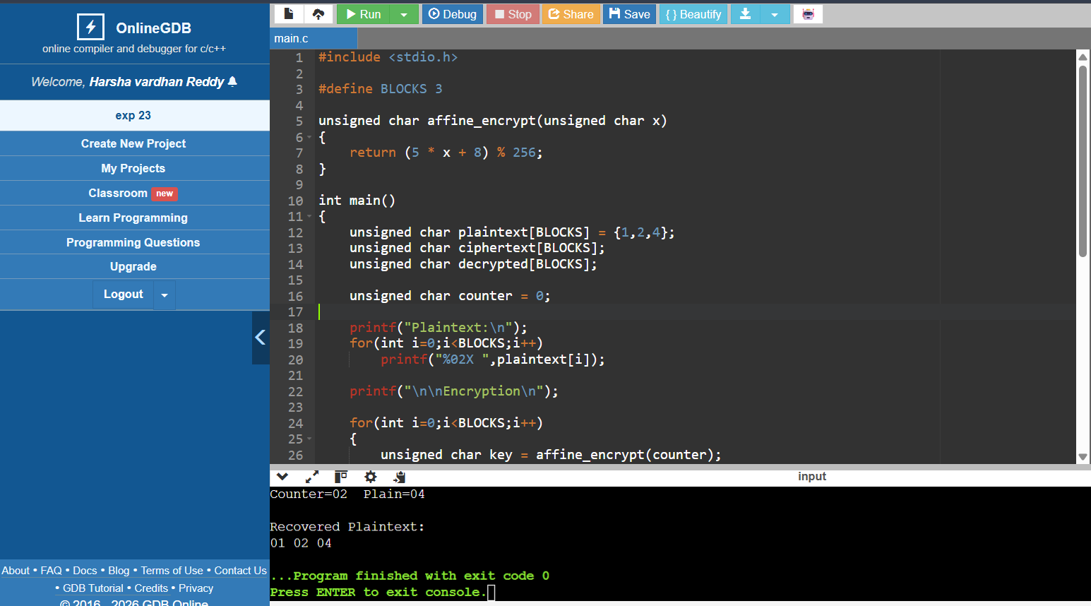

EXPERIMENT 24:
CODE:
#include <stdio.h>

int gcdExtended(int a, int b, int *x, int *y)
{
if(a==0)
{
*x=0;
*y=1;
return b;
}

int x1,y1;

int gcd=gcdExtended(b%a,a,&x1,&y1);

*x=y1-(b/a)*x1;
*y=x1;

return gcd;
}

int main()
{
int e=31;
int phi=3480;

int x,y;

gcdExtended(e,phi,&x,&y);

int d=(x%phi+phi)%phi;

printf("Public Key\n");
printf("e=%d\n",e);
printf("n=3599\n\n");

printf("Private Key\n");
printf("d=%d\n",d);

return 0;
}
OUTPUT:
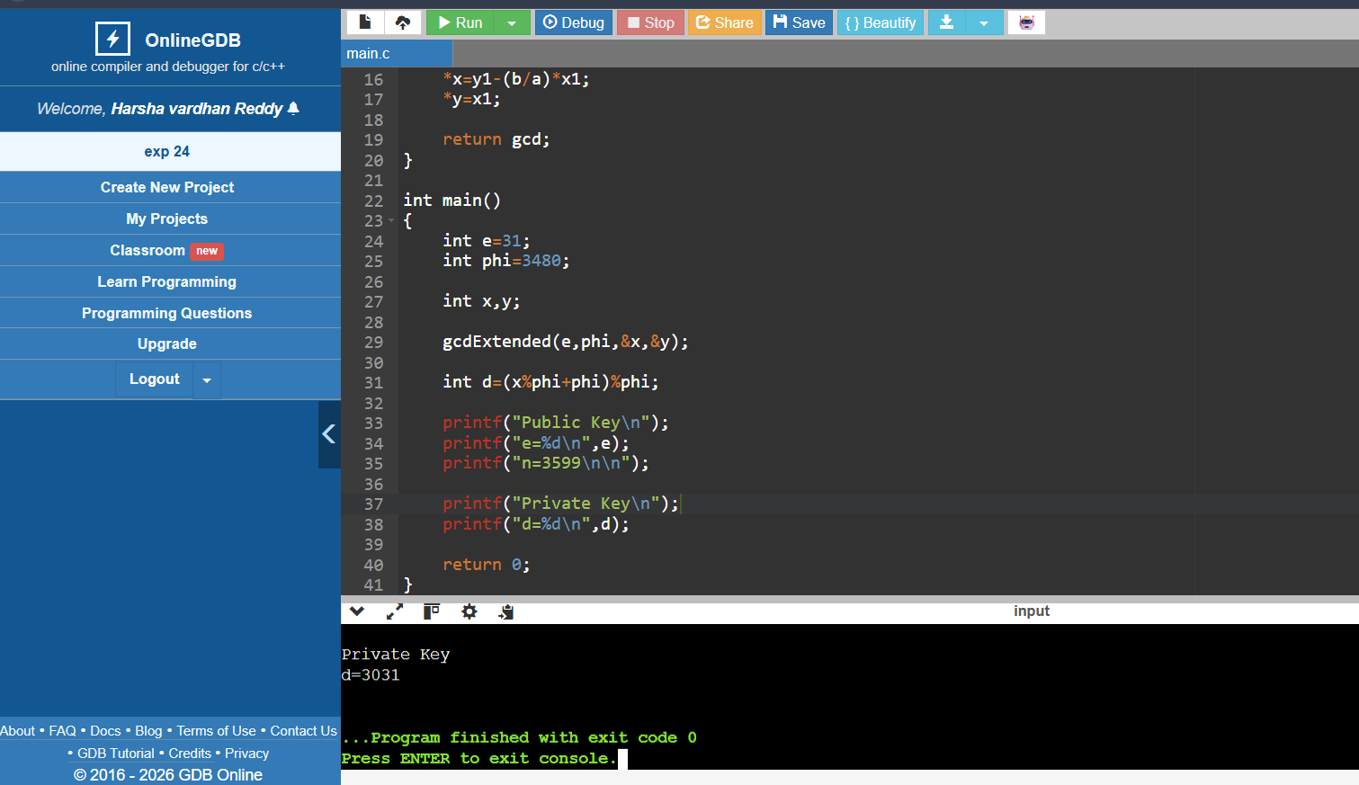

EXPERIMENT 25:
CODE:
#include <stdio.h>

int gcd(int a,int b)
{
while(b!=0)
{
int t=b;
b=a%b;
a=t;
}
return a;
}

int main()
{
int n=3599;
int plaintext=59; // Shares a factor with n

int factor=gcd(plaintext,n);

if(factor>1)
{
printf("Common factor found = %d\n",factor);
printf("Other factor = %d\n",n/factor);
}
else
{
printf("No common factor found.\n");
}

return 0;
}

OUTPUT:
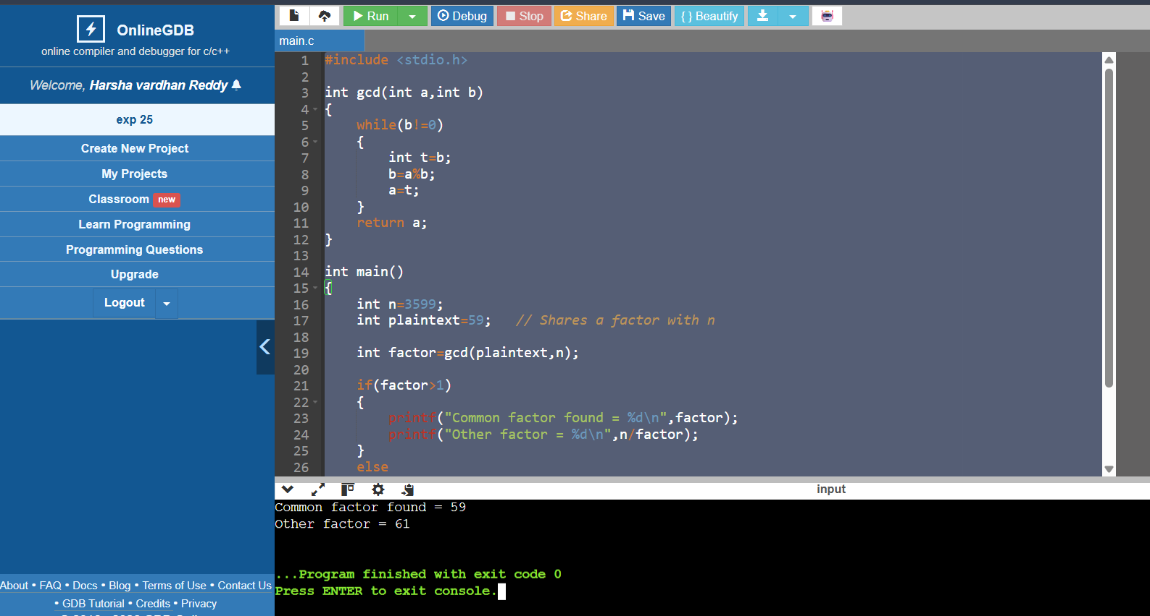

EXPERIMENT 26:
CODE:
#include <stdio.h>
long long modExp(long long base, long long exp, long long mod)
{
long long result = 1;
while(exp > 0)
{
if(exp % 2 == 1)
result = (result * base) % mod;
base = (base * base) % mod;
exp = exp / 2;
}

return result;
}

int main()
{
long long p = 17, q = 11;
long long n = p * q;
long long e = 7;
long long d = 23;
long long message = 88;
long long cipher = modExp(message, e, n);
long long plain = modExp(cipher, d, n);
printf("Public Key (e,n): (%lld,%lld)\n", e, n);
printf("Private Key d = %lld\n", d);
printf("Original Message = %lld\n", message);
printf("Encrypted Message = %lld\n", cipher);
printf("Decrypted Message = %lld\n", plain);
return 0;
}

OUTPUT:
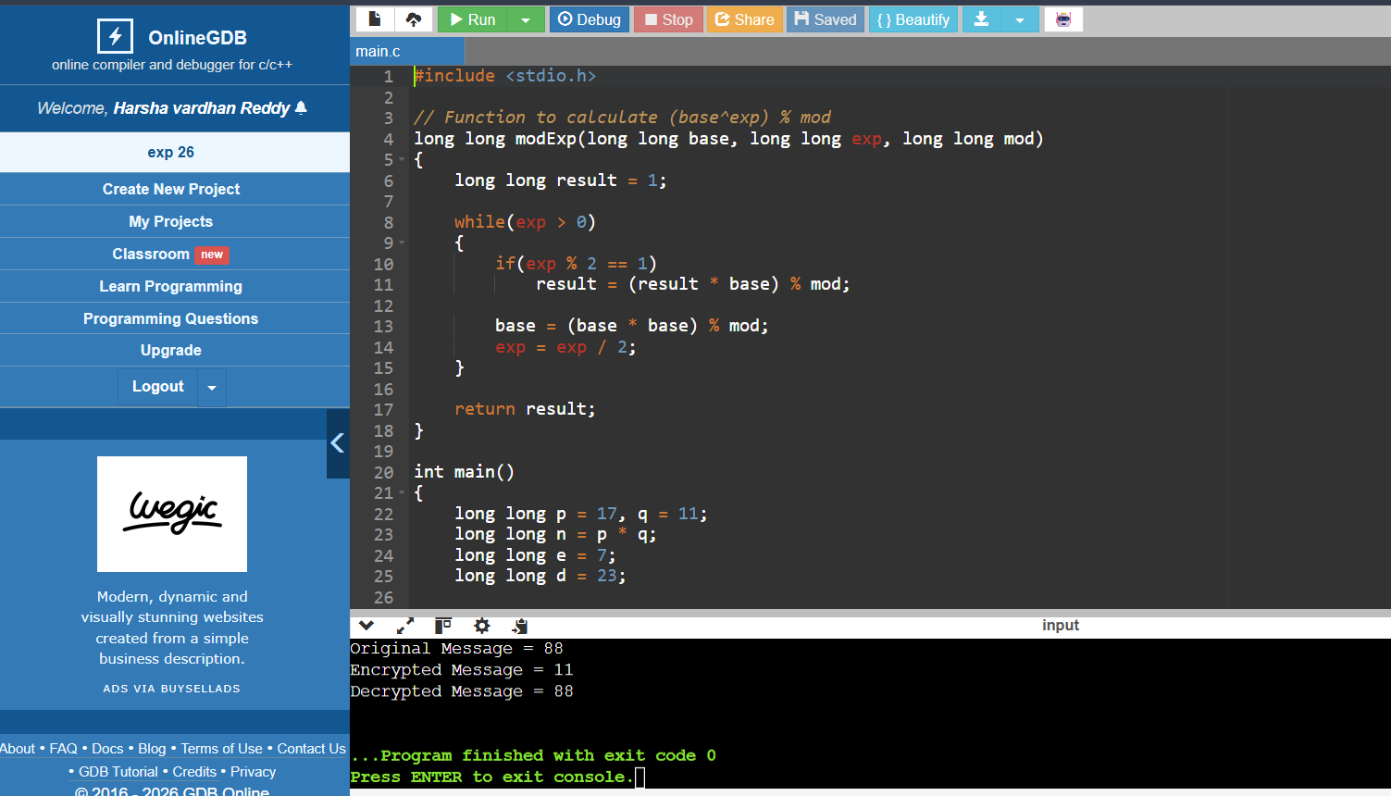

EXPERIMENT 27:
CODE:
#include <stdio.h>

long long modExp(long long base,long long exp,long long mod)
{
long long result=1;

while(exp>0)
{
if(exp%2)
result=(result*base)%mod;

base=(base*base)%mod;
exp/=2;
}

return result;
}

int main()
{
long long e=17,n=3233;
char text[]="HELLO";

printf("Ciphertext:\n");

for(int i=0;text[i]!='\0';i++)
{
int m=text[i]-'A';
printf("%lld ",modExp(m,e,n));
}

printf("\n");

return 0;
}

OUTPUT:
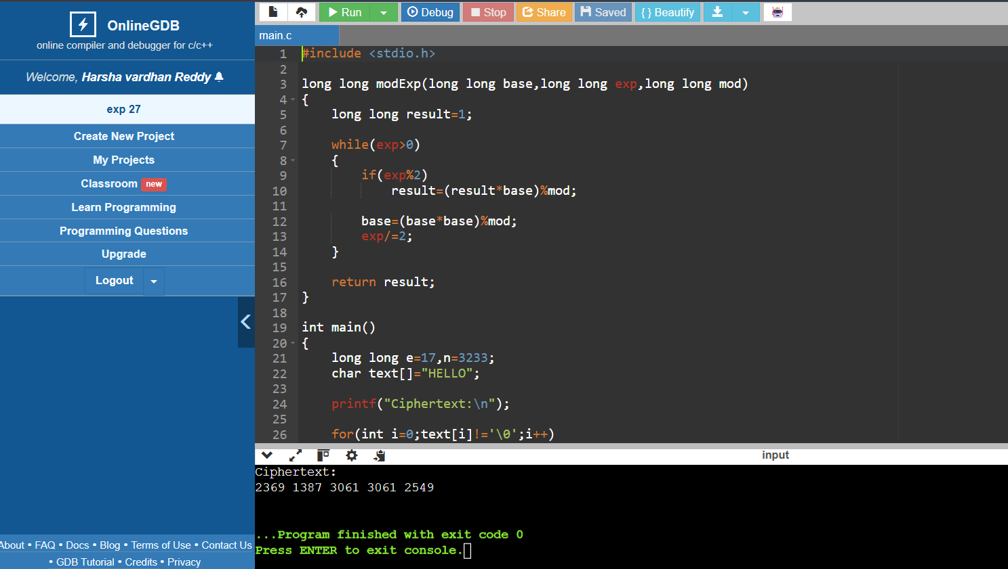

EXPERIMENT 28:
CODE:
#include <stdio.h>

long long power(long long a,long long b,long long mod)
{
long long result=1;

while(b>0)
{
if(b%2)
result=(result*a)%mod;

a=(a*a)%mod;
b/=2;
}

return result;
}

int main()
{
long long q=23;
long long a=5;

long long xa=6;
long long xb=15;

long long Ya=power(a,xa,q);
long long Yb=power(a,xb,q);

long long Ka=power(Yb,xa,q);
long long Kb=power(Ya,xb,q);

printf("Alice Public Value = %lld\n",Ya);
printf("Bob Public Value = %lld\n",Yb);

printf("Alice Key = %lld\n",Ka);
printf("Bob Key = %lld\n",Kb);

return 0;
}

OUTPUT:
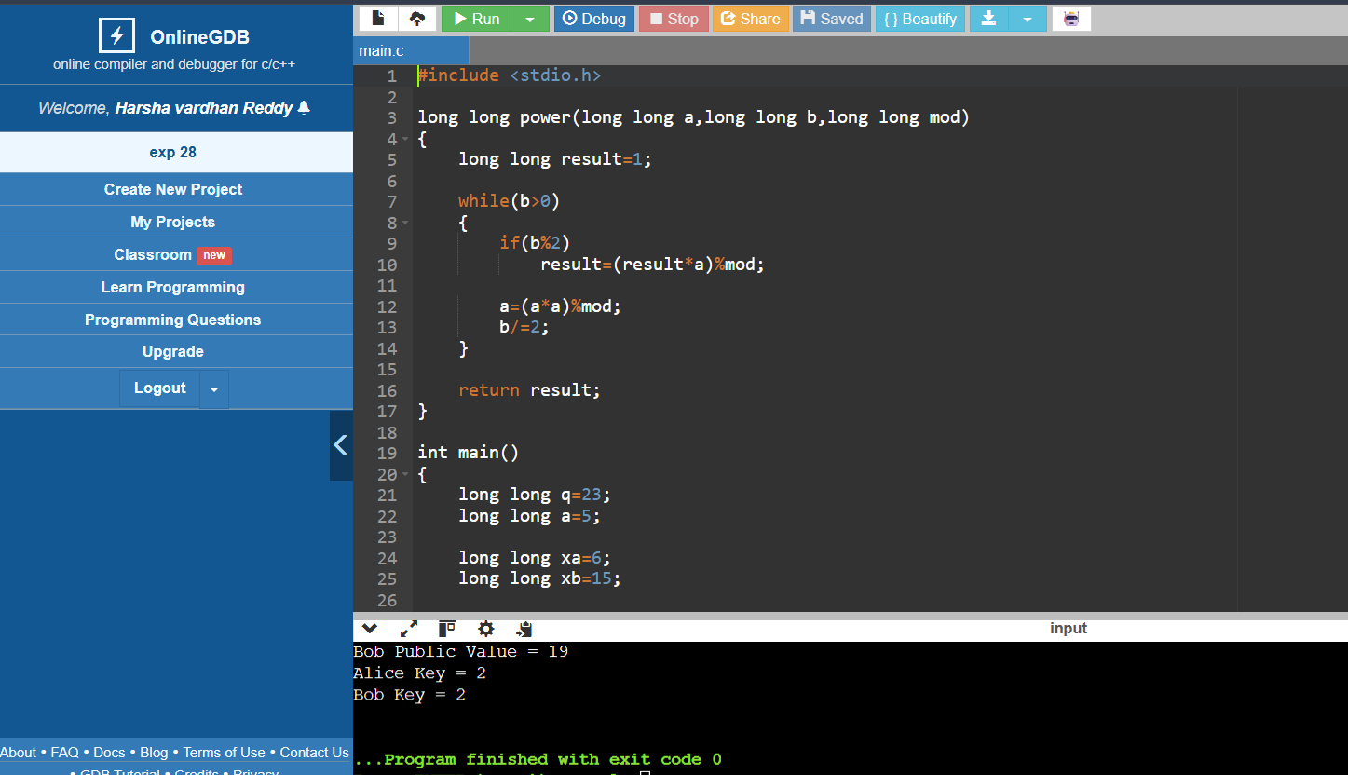

EXPERIMENT 29:
CODE:
#include <stdio.h>

int main()
{
int blockSize = 1024;
int laneSize = 64;

int totalLanes = 1600 / laneSize;
int rateLanes = blockSize / laneSize;
int capacityLanes = totalLanes - rateLanes;

printf("Total Lanes = %d\n", totalLanes);
printf("Rate Lanes = %d\n", rateLanes);
printf("Capacity Lanes = %d\n", capacityLanes);

printf("\nIgnoring permutation,\n");
printf("Capacity lanes never receive message bits.\n");

printf("Therefore capacity lanes remain zero forever.\n");

return 0;
}

OUTPUT:
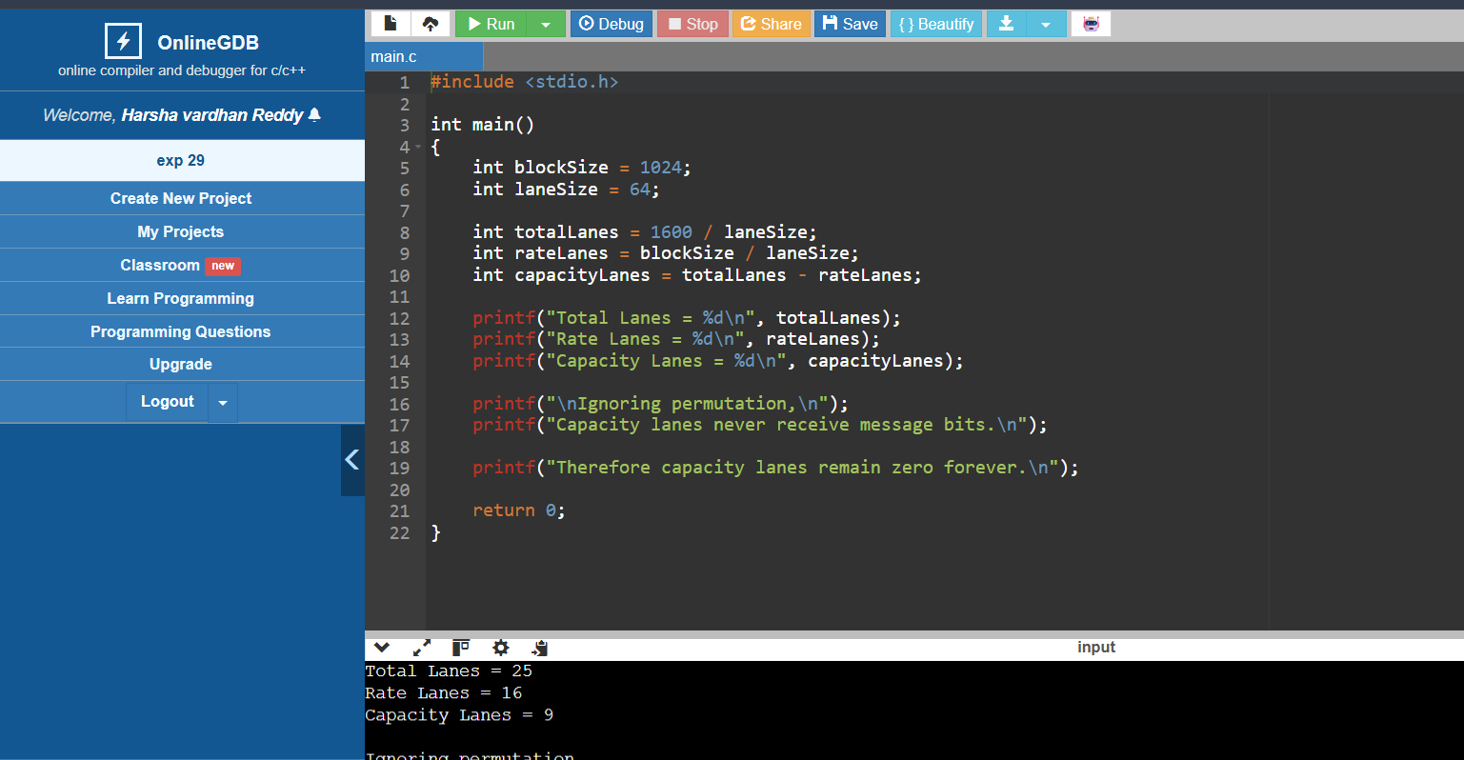

EXPERIMENT 30:
CODE:
#include <stdio.h>

int main()
{
unsigned char X = 0x5A;
unsigned char T = 0xA3;

unsigned char secondBlock = X ^ T;

printf("Message Block X = %02X\n", X);
printf("MAC(X) = %02X\n", T);
printf("Second Block = X XOR T = %02X\n", secondBlock);

printf("\nForged Message = X || (X XOR T)\n");

return 0;
}

OUTPUT:
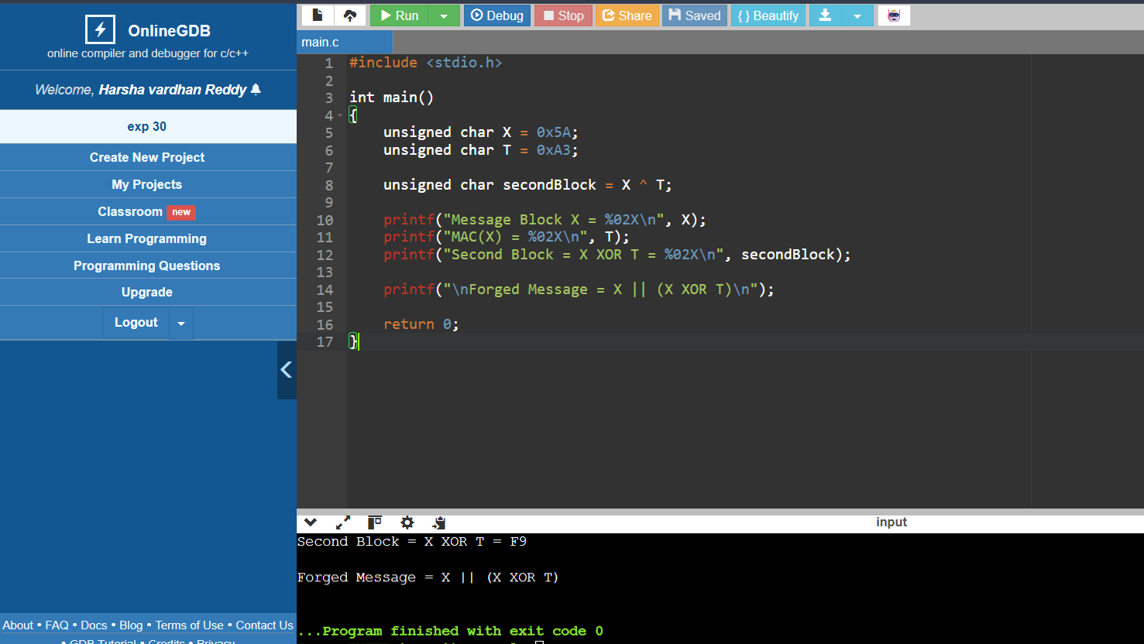

EXPERIMENT 31:
CODE:
#include <stdio.h>
#include <stdint.h>

uint64_t leftShift64(uint64_t x)
{
return x << 1;
}

uint64_t generateK1_64(uint64_t L)
{
uint64_t K1 = leftShift64(L);

if (L & 0x8000000000000000ULL)
K1 ^= 0x1B;

return K1;
}

uint64_t generateK2_64(uint64_t K1)
{
uint64_t K2 = leftShift64(K1);

if (K1 & 0x8000000000000000ULL)
K2 ^= 0x1B;

return K2;
}

int main()
{
uint64_t L, K1, K2;

printf("Enter L in hexadecimal: ");
scanf("%llx", &L);

K1 = generateK1_64(L);
K2 = generateK2_64(K1);

printf("L = %016llX\n", L);
printf("K1 = %016llX\n", K1);
printf("K2 = %016llX\n", K2);

return 0;
}

OUTPUT:
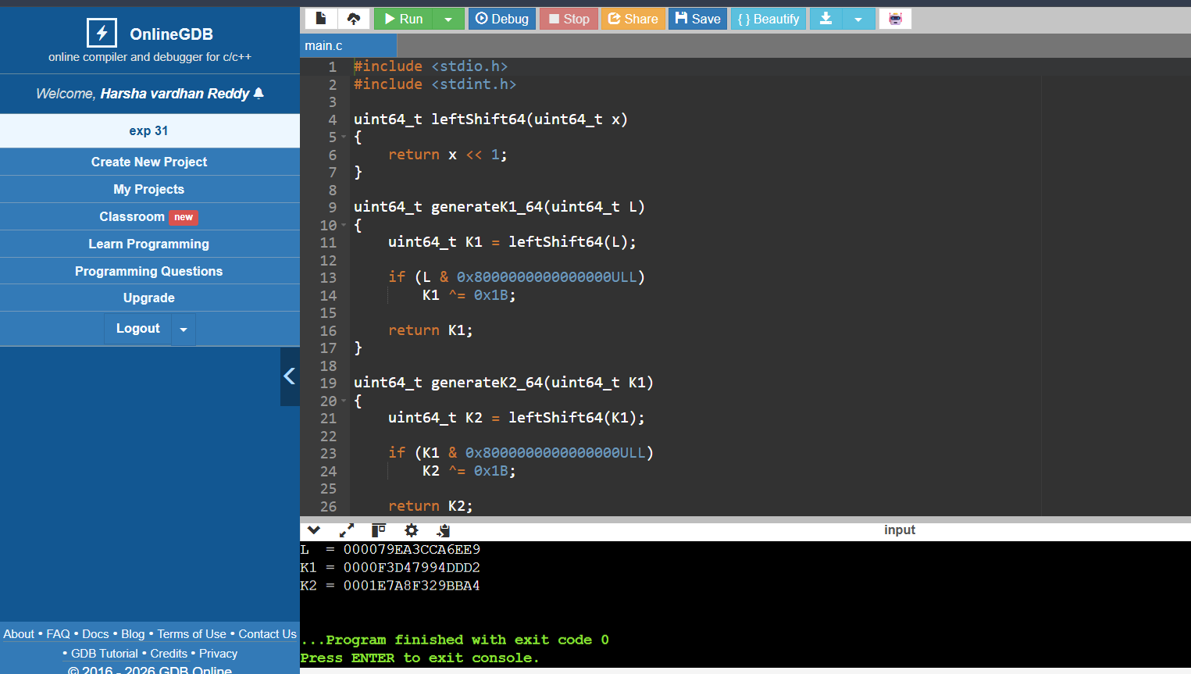
EXPERIMENT 32:
CODE:
#include <stdio.h>

int main()
{
int messageHash;
int k1, k2;
int r1, s1, r2, s2;

printf("Enter message hash: ");
scanf("%d", &messageHash);

printf("Enter k for first signature: ");
scanf("%d", &k1);

printf("Enter k for second signature: ");
scanf("%d", &k2);

/* Simplified DSA demonstration */
r1 = (k1 * 7) % 23;
s1 = (messageHash + k1) % 23;

r2 = (k2 * 7) % 23;
s2 = (messageHash + k2) % 23;

printf("\nFirst Signature : (%d, %d)", r1, s1);
printf("\nSecond Signature: (%d, %d)", r2, s2);

if (r1 != r2 || s1 != s2)
printf("\n\nSignatures are different.");
else
printf("\n\nSignatures are same.");

printf("\nReason: Different k values were used.\n");

return 0;
}

OUTPUT:
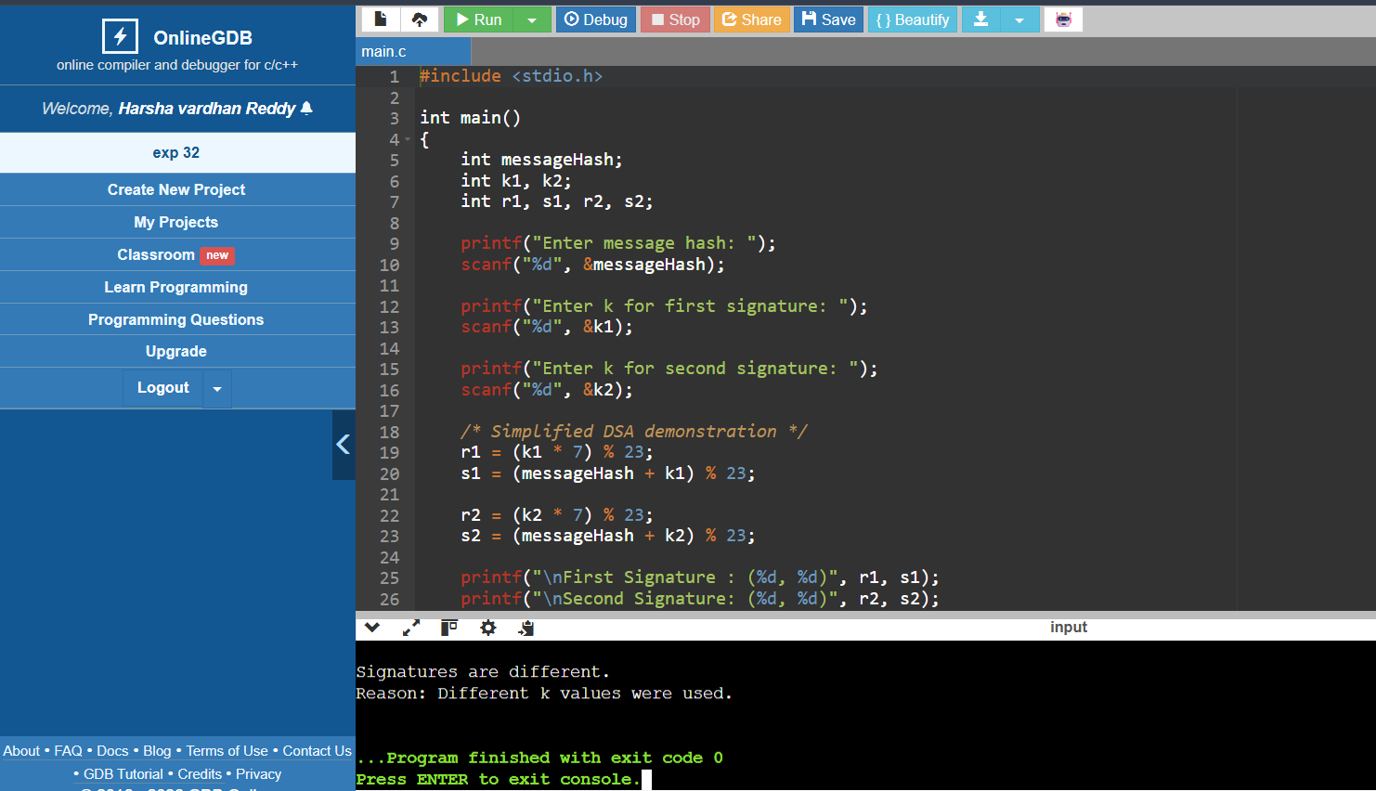

EXPERIMENT 33:
CODE:
#include <stdio.h>
#include <stdint.h>

/* Simplified DES-style demonstration */
uint64_t encrypt(uint64_t data, uint64_t key)
{
int i;

for (i = 0; i < 16; i++)
{
data = ((data << 3) | (data >> 61));
data ^= key + i;
}

return data;
}

uint64_t decrypt(uint64_t data, uint64_t key)
{
int i;

for (i = 15; i >= 0; i--)
{
data ^= key + i;
data = ((data >> 3) | (data << 61));
}

return data;
}

int main()
{
uint64_t plaintext, key;
uint64_t ciphertext, recovered;

printf("Enter plaintext (hex): ");
scanf("%llx", &plaintext);

printf("Enter key (hex): ");
scanf("%llx", &key);

ciphertext = encrypt(plaintext, key);
recovered = decrypt(ciphertext, key);

printf("\nPlaintext : %016llX", plaintext);
printf("\nCiphertext : %016llX", ciphertext);
printf("\nDecrypted : %016llX\n", recovered);

return 0;
}

OUTPUT:
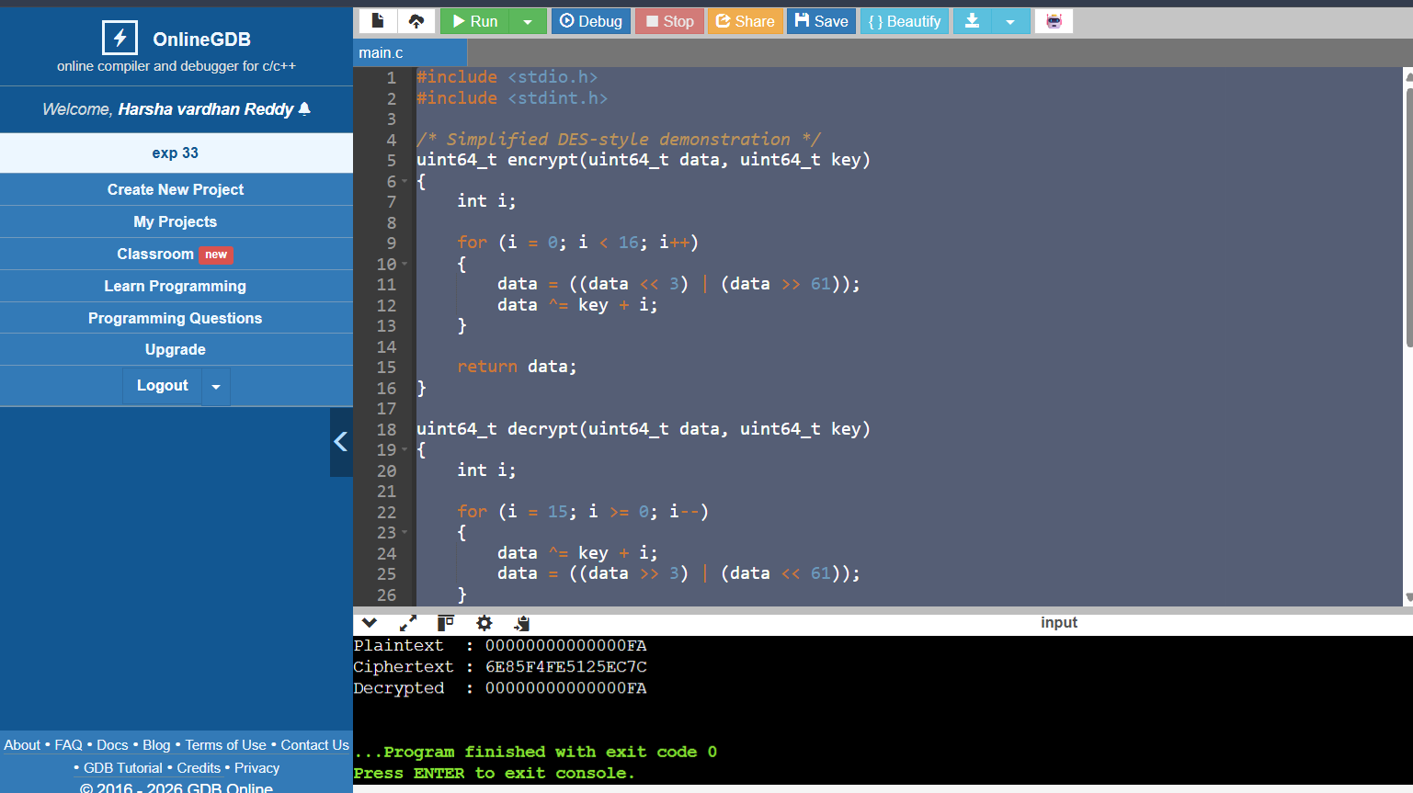

EXPERIMENT 34:
CODE:
#include <stdio.h>
#include <string.h>

#define MAX 100

int encrypt(int block, int key)
{
return block ^ key;
}

/* ECB */
void ECB(char *plain, int key)
{
int i;

printf("ECB Ciphertext: ");

for (i = 0; plain[i] != '\0'; i++)
printf("%02X ", encrypt(plain[i], key));

printf("\n");
}

/* CBC */
void CBC(char *plain, int key, int IV)
{
int i;
int previous = IV;

printf("CBC Ciphertext: ");

for (i = 0; plain[i] != '\0'; i++)
{
int cipher = encrypt(plain[i] ^ previous, key);

printf("%02X ", cipher);
previous = cipher;
}

printf("\n");
}

/* CFB */
void CFB(char *plain, int key, int IV)
{
int i;
int previous = IV;

printf("CFB Ciphertext: ");

for (i = 0; plain[i] != '\0'; i++)
{
int stream = encrypt(previous, key);
int cipher = plain[i] ^ stream;

printf("%02X ", cipher);
previous = cipher;
}

printf("\n");
}

int main()
{
char plaintext[MAX];
int key, IV;

printf("Enter plaintext: ");
fgets(plaintext, MAX, stdin);

plaintext[strcspn(plaintext, "\n")] = '\0';

printf("Enter key: ");
scanf("%d", &key);

printf("Enter IV: ");
scanf("%d", &IV);

printf("\n");

ECB(plaintext, key);
CBC(plaintext, key, IV);
CFB(plaintext, key, IV);

return 0;
}

OUTPUT:
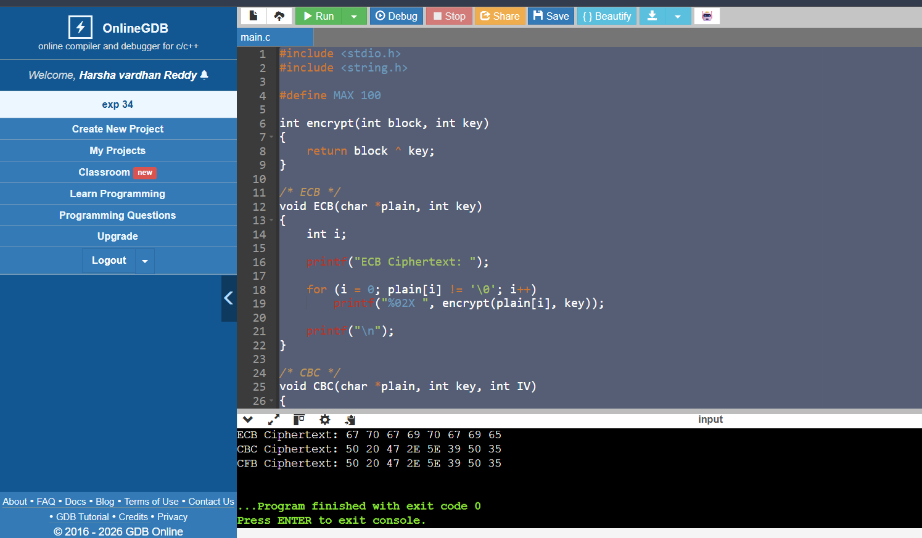
EXPERIMENT 35:
CODE:
#include <stdio.h>
#include <string.h>
#include <ctype.h>

int main()
{
char plaintext[100];
int key[100];
int n, i;
char ciphertext[100];
char decrypted[100];

printf("Enter plaintext: ");
fgets(plaintext, sizeof(plaintext), stdin);

plaintext[strcspn(plaintext, "\n")] = '\0';

n = strlen(plaintext);

printf("Enter %d key values (0-25):\n", n);

for (i = 0; i < n; i++)
scanf("%d", &key[i]);

/* Encryption */
for (i = 0; i < n; i++)
{
if (isalpha(plaintext[i]))
{
int p = toupper(plaintext[i]) - 'A';

ciphertext[i] =
((p + key[i]) % 26) + 'A';
}
else
{
ciphertext[i] = plaintext[i];
}
}

ciphertext[n] = '\0';

/* Decryption */
for (i = 0; i < n; i++)
{
if (isalpha(ciphertext[i]))
{
int c = ciphertext[i] - 'A';

decrypted[i] =
((c - key[i] + 26) % 26) + 'A';
}
else
{
decrypted[i] = ciphertext[i];
}
}

decrypted[n] = '\0';

printf("\nCiphertext : %s", ciphertext);
printf("\nDecrypted : %s\n", decrypted);

return 0;
}

OUTPUT:
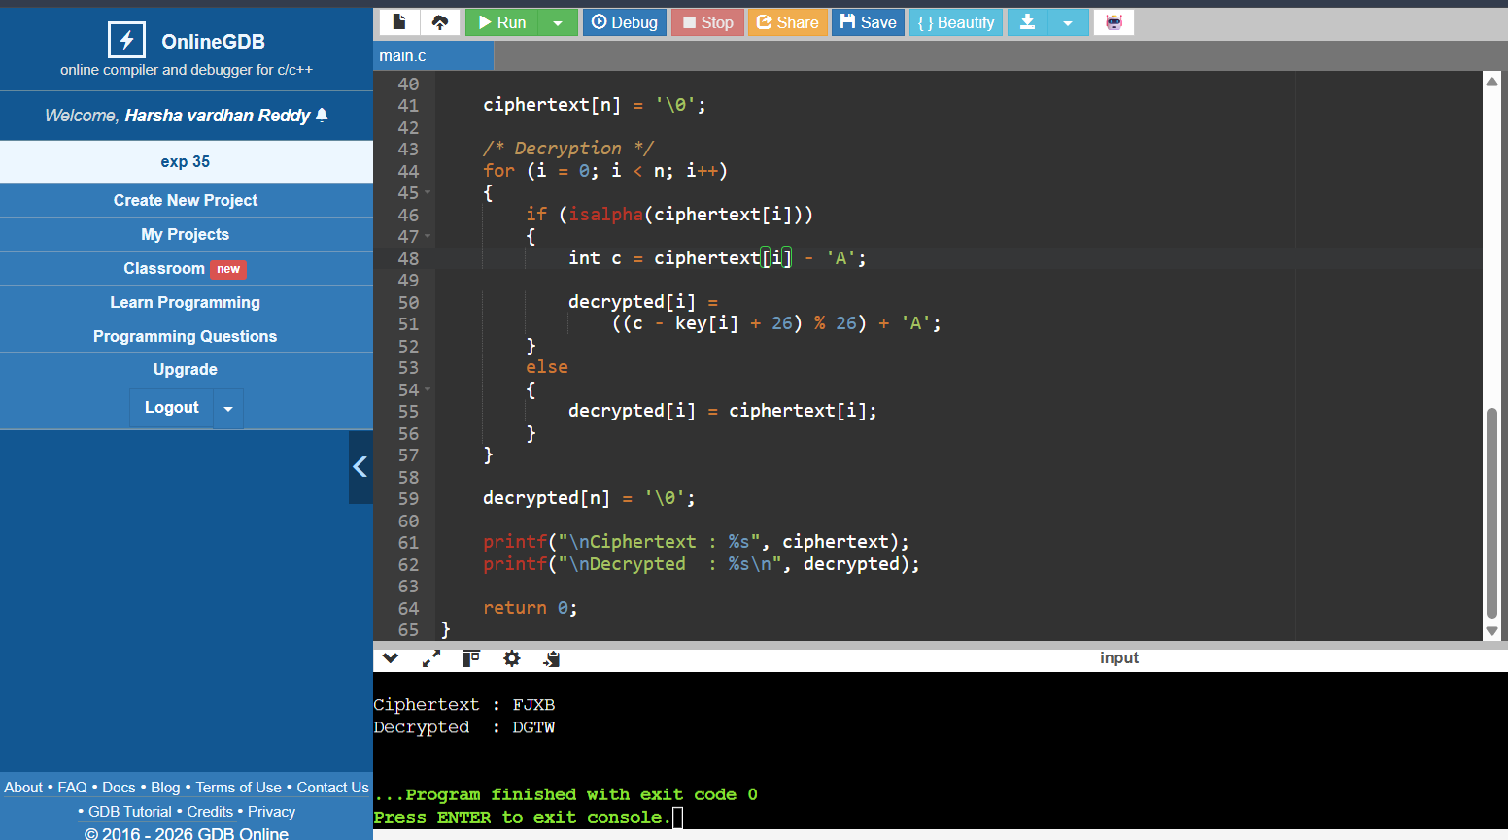

EXPERIMENT 36:
CODE:
#include <stdio.h>
#include <ctype.h>
#include <string.h>

int gcd(int a, int b)
{
while (b != 0)
{
int temp = b;
b = a % b;
a = temp;
}

return a;
}

int main()
{
char plaintext[100], ciphertext[100];
int a, b, i;

printf("Enter plaintext: ");
fgets(plaintext, sizeof(plaintext), stdin);

printf("Enter a: ");
scanf("%d", &a);

printf("Enter b: ");
scanf("%d", &b);

if (gcd(a, 26) != 1)
{
printf("Invalid a. gcd(a,26) must be 1.\n");
return 0;
}

for (i = 0; plaintext[i] != '\0'; i++)
{
if (isalpha(plaintext[i]))
{
int p = toupper(plaintext[i]) - 'A';

ciphertext[i] =
((a * p + b) % 26) + 'A';
}
else
{
ciphertext[i] = plaintext[i];
}
}

ciphertext[i] = '\0';

printf("Ciphertext: %s", ciphertext);

return 0;
}

OUTPUT:
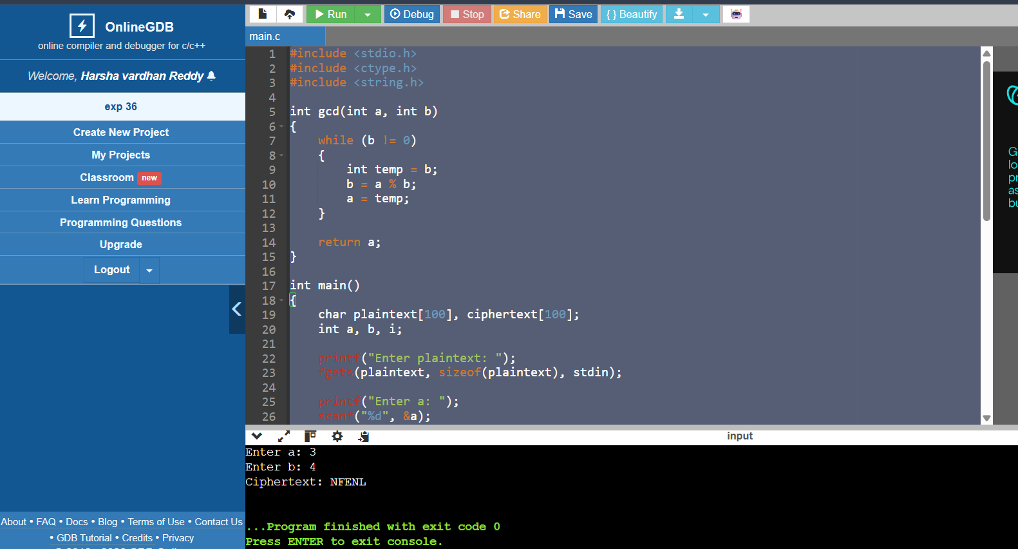

EXPERIMENT 37:
CODE:
#include <stdio.h>
#include <ctype.h>
#include <string.h>

int main()
{
char cipher[500];
char english[] = "ETAOINSHRDLCUMWFGYPBVKJXQZ";

int freq[26] = {0};
int order[26];
int i, j, temp;

printf("Enter ciphertext: ");
fgets(cipher, sizeof(cipher), stdin);

/* Count frequency */
for (i = 0; cipher[i] != '\0'; i++)
{
if (isalpha(cipher[i]))
freq[toupper(cipher[i]) - 'A']++;
}

for (i = 0; i < 26; i++)
order[i] = i;

/* Sort by frequency */
for (i = 0; i < 25; i++)
{
for (j = i + 1; j < 26; j++)
{
if (freq[order[j]] > freq[order[i]])
{
temp = order[i];
order[i] = order[j];
order[j] = temp;
}
}
}

printf("\nPossible plaintext:\n");

for (i = 0; cipher[i] != '\0'; i++)
{
if (isalpha(cipher[i]))
{
int c = toupper(cipher[i]) - 'A';

for (j = 0; j < 26; j++)
{
if (order[j] == c)
{
printf("%c", english[j]);
break;
}
}
}
else
{
printf("%c", cipher[i]);
}
}

return 0;
}

OUTPUT:


EXPERIMENT 38:
CODE:
#include <stdio.h>

int inverse(int a)
{
int i;

a = (a % 26 + 26) % 26;

for (i = 1; i < 26; i++)
{
if ((a * i) % 26 == 1)
return i;
}

return -1;
}

int main()
{
int P[2][2], C[2][2], Pinv[2][2], K[2][2];
int det, invDet;
int i, j, k;

printf("Enter plaintext matrix P:\n");

for (i = 0; i < 2; i++)
for (j = 0; j < 2; j++)
scanf("%d", &P[i][j]);

printf("Enter ciphertext matrix C:\n");

for (i = 0; i < 2; i++)
for (j = 0; j < 2; j++)
scanf("%d", &C[i][j]);

det = (P[0][0] * P[1][1] -
P[0][1] * P[1][0]) % 26;

if (det < 0)
det += 26;

invDet = inverse(det);

if (invDet == -1)
{
printf("P has no inverse modulo 26.\n");
return 0;
}

/* Inverse of P */
Pinv[0][0] = (P[1][1] * invDet) % 26;
Pinv[0][1] = (-P[0][1] * invDet) % 26;
Pinv[1][0] = (-P[1][0] * invDet) % 26;
Pinv[1][1] = (P[0][0] * invDet) % 26;

for (i = 0; i < 2; i++)
for (j = 0; j < 2; j++)
if (Pinv[i][j] < 0)
Pinv[i][j] += 26;

/* K = C * P^-1 */
for (i = 0; i < 2; i++)
{
for (j = 0; j < 2; j++)
{
K[i][j] = 0;

for (k = 0; k < 2; k++)
K[i][j] += C[i][k] * Pinv[k][j];

K[i][j] %= 26;
}
}

printf("\nRecovered Key Matrix:\n");

for (i = 0; i < 2; i++)
{
for (j = 0; j < 2; j++)
printf("%d ", K[i][j]);

printf("\n");
}

return 0;
}

OUTPUT:
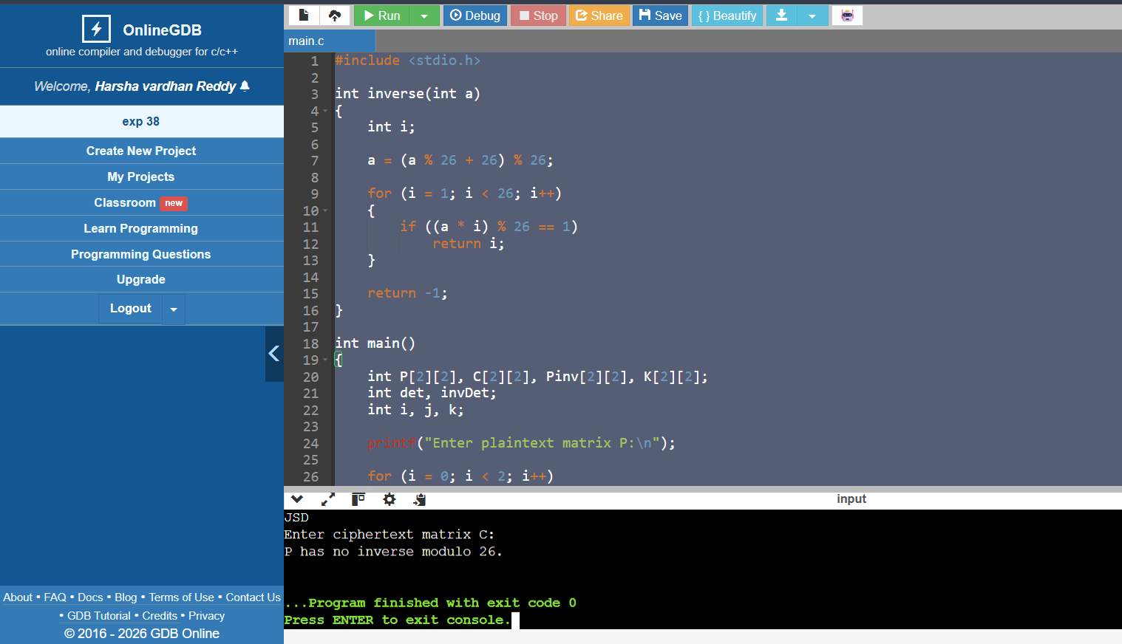

EXPERIMENT 39:
CODE:
#include <stdio.h>
#include <ctype.h>

int main()
{
char cipher[500];
int freq[26] = {0};
int i, max = 0, maxIndex = 0;
int key;

printf("Enter ciphertext: ");
fgets(cipher, sizeof(cipher), stdin);

/* Count frequency */
for (i = 0; cipher[i] != '\0'; i++)
{
if (isalpha(cipher[i]))
freq[toupper(cipher[i]) - 'A']++;
}

/* Find most frequent letter */
for (i = 0; i < 26; i++)
{
if (freq[i] > max)
{
max = freq[i];
maxIndex = i;
}
}

/* Assume most frequent letter is E */
key = (maxIndex - 4 + 26) % 26;

printf("\nMost frequent letter: %c\n",
maxIndex + 'A');

printf("Possible key: %d\n", key);

printf("Possible plaintext: ");

for (i = 0; cipher[i] != '\0'; i++)
{
if (isalpha(cipher[i]))
{
int c = toupper(cipher[i]) - 'A';
int p = (c - key + 26) % 26;

printf("%c", p + 'A');
}
else
{
printf("%c", cipher[i]);
}
}

printf("\n");

return 0;
}

OUTPUT:
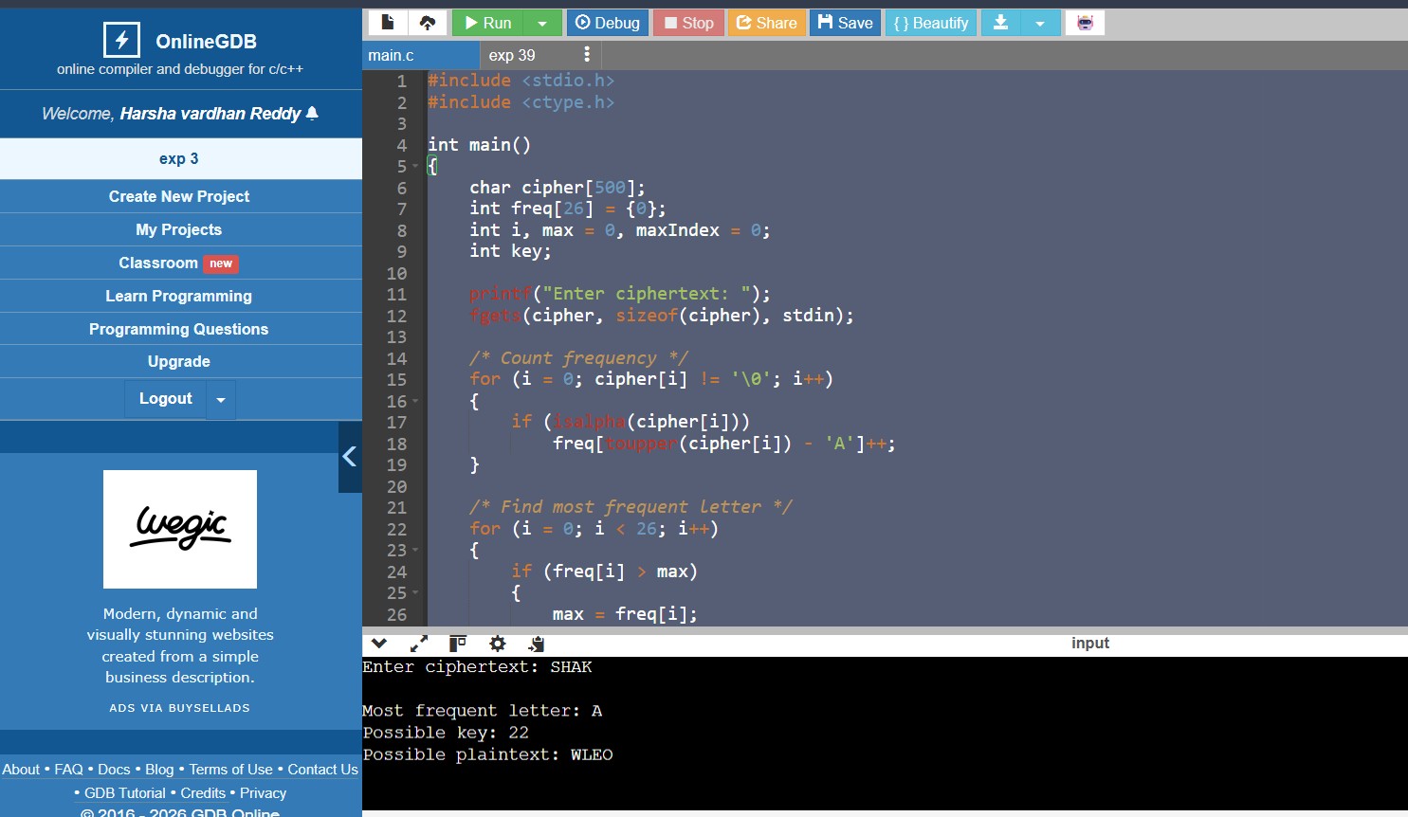

EXPERIMENT 40:
CODE:
#include <stdio.h>
#include <ctype.h>
#include <string.h>

void decrypt(char *cipher, int shift, char *plain)
{
int i;

for (i = 0; cipher[i] != '\0'; i++)
{
if (isalpha(cipher[i]))
{
int c = toupper(cipher[i]) - 'A';
plain[i] = ((c - shift + 26) % 26) + 'A';
}
else
{
plain[i] = cipher[i];
}
}

plain[i] = '\0';
}

int main()
{
char cipher[500];
char plain[500];
int freq[26] = {0};
int i, j, max, maxIndex;

printf("Enter ciphertext: ");
fgets(cipher, sizeof(cipher), stdin);

/* Count frequency */
for (i = 0; cipher[i] != '\0'; i++)
{
if (isalpha(cipher[i]))
freq[toupper(cipher[i]) - 'A']++;
}

/* Find most frequent letter */
max = 0;
maxIndex = 0;

for (i = 0; i < 26; i++)
{
if (freq[i] > max)
{
max = freq[i];
maxIndex = i;
}
}

printf("\nTop 10 possible plaintexts:\n\n");

/*
Try 10 shifts near the probable shift.
*/
for (j = 0; j < 10; j++)
{
int key = (maxIndex - 4 + j + 26) % 26;

decrypt(cipher, key, plain);

printf("%d. %s", j + 1, plain);
}

return 0;
}
OUTPUT:

